NAME SURNAME: NO: GRADE:5/B
- WRITE CORRECT SENTENCES ACCORDING TO THE TABLE. COMPLETE “ME” PART ABOUT YOURSELF(20P)
 |  | 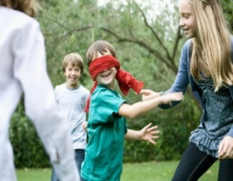 | 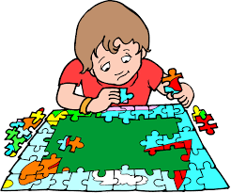 | 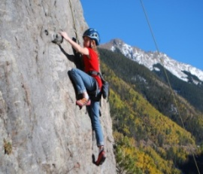
MIKE
MARY
ME
- Mike likes fishing but he doesn’t likeclimbing a mountain.
- MaryLIKES PLAYING BLIND MAN’S BUFF BUT SHE DOESN’T LIKE DOING PUZZLE.
- I LIKE …………………………. BUT I DON’T LIKE ………………………………….

- WRITE CORRECT SENTENCES ACCORDING TO THE TABLE. COMPLETE “ME” PART ABOUT YOURSELF (20P)
MIKE |  | x
MARY |  |  |  | x
ME
- Mike can dance but he can’t do magic.
- MaryCAN PLAY YO-YO BUT SHE CAN’T SING A SONG.
- I CAN ………………………. BUT I CAN’T …………………………
- MATCH THE WORDS WITH THE PICTURES (20P)
- Get up -have dinner - go online – watch TV– wash my face
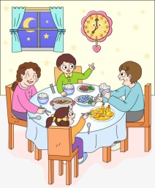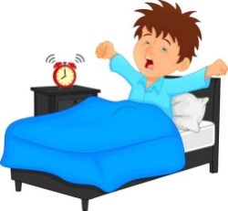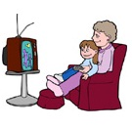
WASH MY FACE HAVE DINNER GET UP WATCHT TV GO ONLINE
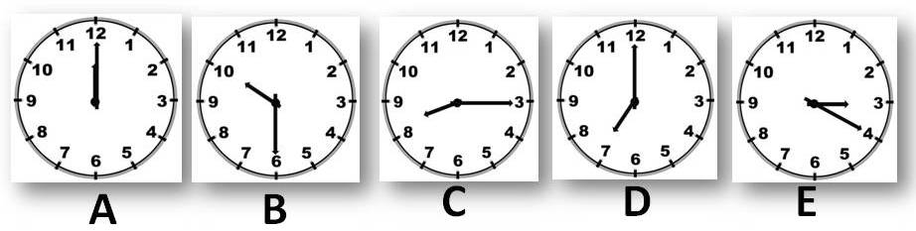
- MATCH THE TIME SENTENCES WITH THE CLOCKS (20P)

- It’s seven o’clock. (…D……) 4. It’s quarter past eight. (…C……)
- It’s twelve o’clock (…A……) 5. It’s twenty past three. (…E……)
- It’s half past ten (……B….)

- WRITE THE NUMBERSIN ENGLISH (10P)
11: Eleven | 44: FORTY-FOUR
13: THIRTEEN | 82: EIGHTY-TWO
18: EIGHTEEN | 93: NINETY-THREE

- MATCH THE NAMES OF THE ILLNESSES WITH PICTURES(10P)
- Runny nose-Backache – Toothache- Cough– Measles Stomachache

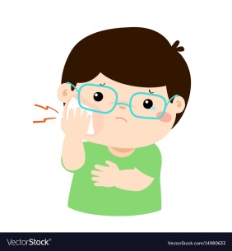 |  |  | 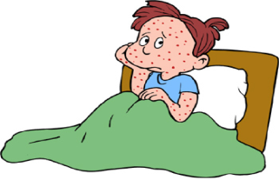 | 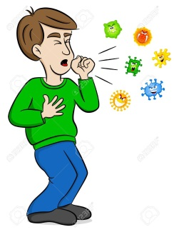
TOOTHACHE | RUNNY NOSE | BACKACHE | MEASLES | COUGH

………………
İngilizce Öğretmeni

