………….………………. ORTAOKULU 5. SINIF 1. DÖNEM 2. SEÇMELİ İNGİLİZCE SINAVI
Name/Surname: Class: Number Score:______/100

A) Soruları uygun seçeneği işaretleyerek cevaplayınız.(20x4=80 puan)
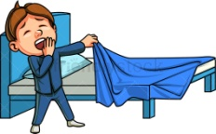
1. Tim: What time do you go to bed?
Sam: .......................................... .
A) At half past six
B) I read a book before sleeping
C) He has lunch in the school canteen
D) I wash my face and hands

2. I .................... home at seven o'clock,
and we ....................... dinner at eight o'clock
A) arrives / get
B) comes / has
C) wash / arrives
D) arrive /have

3. Daisy: ........................................?
Pam : I go to school on foot every morning.
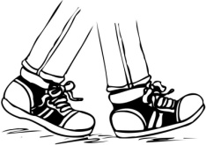
A) Where do you work
B) What is the name of your school
C) How do you go to school
D) When do you go shopping

4. Bruce : ................................. ?
David : It's on Wednesday and Thursdayevenings.
A) When is your swimming course
B) Can you play computer games
C) Do you have a bike
D) Where do you ride a horse

5. Pelin: I can play checkers. What aboutyou?
Rafet: Me too. ........................... .
Pelin: Good idea!
A) I am really good at it
B) I don't enjoy it much
C) Let's play it, then
D) It's my favorite

6. A: ............................ .
B: Me too. See you after school.
A) Glad to meet you
B) No, not really
C) English is my favourite
D) Hello, I'm Deniz

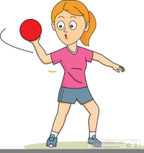
7. My sister is 5 years old and sheloves playing .......................
A) dodgeball
B) hide-and-seek
C) hopscotch
D) tic-tac-toe

8.
Hi, I'm Pakize. I enjoy singing
and dancing, and I am good at them
But I don't like doing puzzle or origami
because I am really bad at them.

Yukarıdaki metne göre seçeneklerden
hangisi yanlıştır?
A) Pakize likes singing.
B) Pakize can dance.
C) Pakize doesn't enjoy singing.
D) Doing origami is Pakize's hobby

9. Ann: Do you collect stamps?
Alex: ....................................
A) I can skip rope and play basketball
B) I like swimming
C) No, I can't, but I like taking photos
D) I can't dance.

10. Aras: We can play tic-tac-toe.
Hazar : Oh, no! ............................ It's not fun.
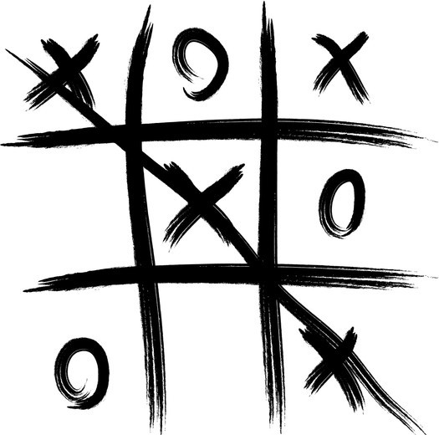
A) I hate it
B) I love it
C) Good idea
D) It's my favorite

11.Verilen görselegöre cevaplayınız.
I'm going to a ............................
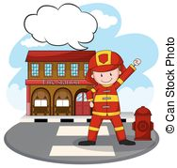
A) bank
B) theater
C) supermarket
D) fire station

12.Aşağıdaki boşluklar doldurulduğundaseçeneklerden hangisi açıkta kalır?
Ahmet lives in Kütahya. His mother is American. Her father is .............. Turkey. Ahmet studies at a(n) ................. school. He loves learning ..................... He can speak Turkish, Indian and English.
A) student
B) favorite
C) languages
D) elementary

13.Cümledeki boşluğa seçeneklerden
hangisi getirilemez?
My favorite class is .............................. .
A) social studies
B) primary school
C) science
D)art

14. My grandparents ................... watching TV.
A)can
B)can’t
C)likes
D)like

15. ………… they do homework?
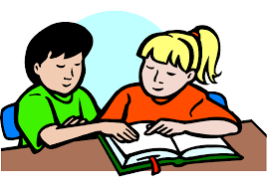
A) Does
B) Do
C) Like
D) Who

16. Ural: What time does she get up every Saturday?
Altay: ………………………………… .
A) She gets up at home
B) She likes breakfast
C) She gets up at nine o’clock
D) She eats kebap

17. He ............. on the bus and goes to school.
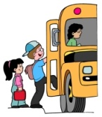
A) goes
B) has
C) likes
D) gets

18. Nick .................. lunch at half past twelve
A)have
B)has
C)get
D)like

19. I get dressed ............... the morning.
A)in
B)on
C)at
D)to

20. Altı çizili kelimelerden hangisi hatalı yazılmıştır.
Betty's English class startathalfpast eight.
A)past
B)half
C)start
D)at

E) Fill ın the blanks wıth “can” or “can’t”(7x3=21 puan)
Activities | Ali | Eda | Mert
 | x | x
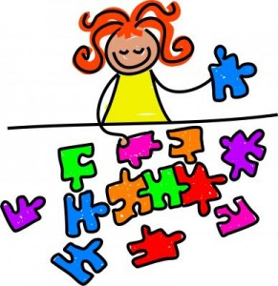 |  | x | x
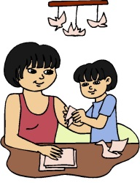 | x

1.Ali …………………………..... do origami.

2.Eda ………………………..…. play football.

3.Mert …………………….…….. do origami..

4. Eda and Mert ……………….………. do puzzles.

5. Ali and Eda…………………………….. play football.

6.Mert …………………………….….. play football.

7. Eda …………………….…………. do origami.

