**[..............ACADEMIC YEAR ……………… SECONDARY SCHOOL 5th GRADERS 1st TERM 2nd WRITTEN EXAM](https://www.sorubak.com)**

**NAME:**……………………………………………**SURNAME:**……………………………………**CLASS:**……………**NUMBER:**…………

1. 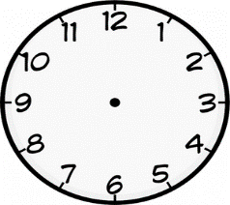**[](https://www.sorubak.com/sinav/)[](https://www.sorubak.com/sinav/)****Match the sentences with the clocks below. (**Verilencümlelerisaatlerleeşleştiriniz**.) 3x5=15pt**

**1 2. 3. 4. 5.**

**12:30 10:00 07:10 06:15 5:45**

(………) It is ten o’clock. (……….) It is a quarter to six. (……..) It is half past twelve.

(………) It is ten past seven. (………) It is a quarter past six

1. **Match the questions with the answers. (**Sorularlacevaplarıeşleştiriniz**.)3x5=15pt**
2. Do you like playing hopscotch? ( )Yes, I can.
3. What do you do in the afternoons? ( )Yes, she does.
4. Does she like playing keepy uppy? ( )I have lunch in the afternoons.
5. What time do you get up? ( )No, I don’t.
6. Can you play checkers? ( )At 7:30.

**C.Complete the phrases and match them with the pictures.(8x2=16)**



1. **According to the table, fill in the blanks with “CAN “, “CAN’T “2x10=20**
2. 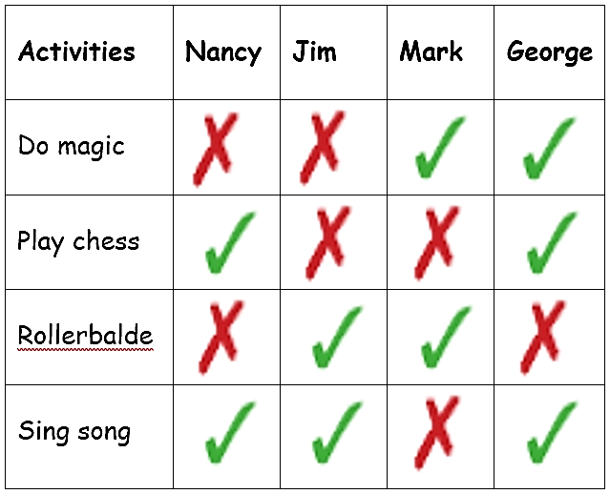Nancy………………………rollerblade.
3. George…………………….sing song.
4. Jim and Mark……………….play chess.
5. George………………………rollerblade.
6. Jim…………………….do magic.
7. Nancy………………..sing song.
8. Mark………………..sing song.

Rollerblade

1. Nancy and George……………..play chess.
2. Jim………………rollerblade.

10.Mark………………….do magic.

1. **Circle the correct verbs.(**Koyuyazılanfiillerdendoğruolanıyuvarlakiçinealınız**)2x5=10pt**
2. Marry**like / likes** playing hopscotch.
3. **Does / Do** Sam like playing hide and seek?
4. You **like / likes** playing chess.
5. I **likes / like** doing puzzles.
6. **Do / Does** you like playing dodgeball?

**F. Doğruşıklarıseçiniz. (8*2=16 pts)**

**1.We like playing …………………… man’s buff.**

a) blind b) art c) book d) good

**2. I am bored. Let’s play ……………………………**

a) board b) drawing c) checkers d) music

**3.[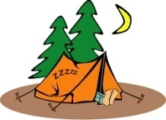](https://www.sorubak.com/sinav/) My sister has a hobby. She likes ………………**

a) playing chess b) camping

c) taking photos d) reading book

**4. Deniz: ……………… does Ece get up?**

**Ferit: ………… six o’clock.**

a) What / On b) Where / On

c) What time / At d) How many / At

**5. Elif: …………… is the post office?**

**Beren: Go straight ……… and turn right.**

a) When / up b) How / down

c) Where / ahead d) What / past

**6. Laura likes …………… in her free time and she is at the …………………… now.**

a) swimming / bakery b) walking / bank

c) sleeping / chemist’s d) reading / library

**7**.



a) singing and dancing b) playing volleyball

c) going camping d) fishing

**8) 02:30 What time is it?**

a) It is two o’clock. c) It is a quarter past two. b) It is half past two. d) It is a quarter to two

**CEVAP ANAHTARI:YOUTUBE**