2022-2023 EĞİTİM ÖĞRETİM YILI ……………. ORTAOKULU 5. SINIFLAR 1. DÖNEM 2. İNGİLİZCE SINAVI
Name Surname: No: Class: 5/ ….
1-Aşağıdaki kelimeleri resimlerin altına doğru olacak şekilde yazınız. (15p)

climbing mountain – hopscotch – doing puzzle - hide and seek - hangman
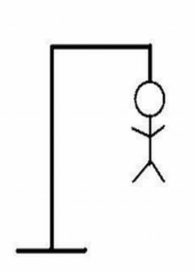
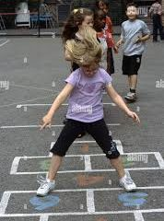
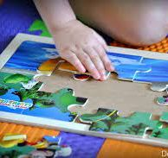
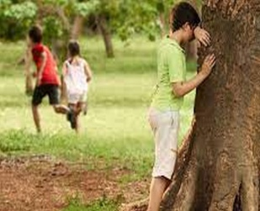

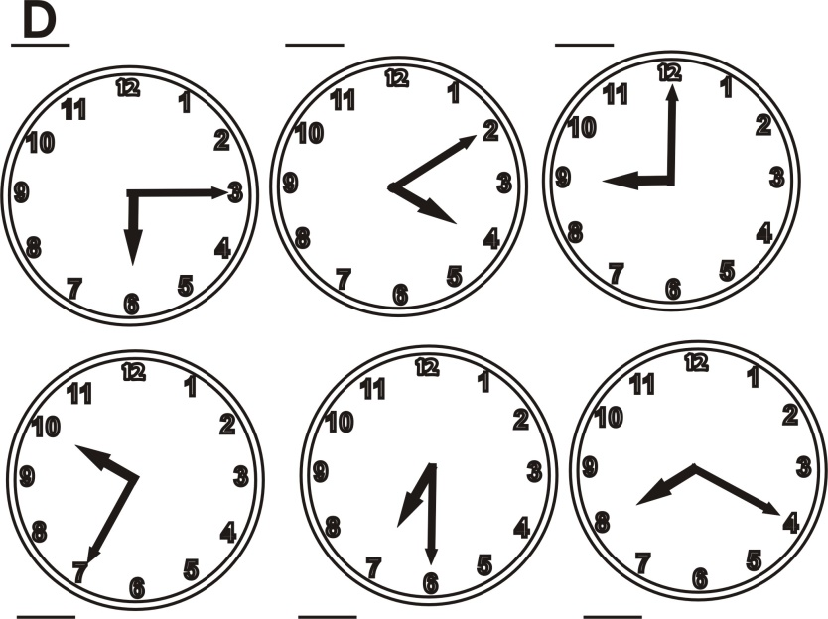
2- Aşağıdaki okunuşu verilen zamanları saatler ile eşleştiriniz. (15 p)

A-It is ten past four.
B-It is half past seven
C-It is nine o’clock
D-It is quarter past six.
E-It is twenty-five to ten.
F- It is twenty past eight.

3- Aşağıdaki tabloya ve emojilerin karşılıklarına bakarak ifadelerin sonundaki boşluklara True (Doğru) ya da False (yanlış) yazınız. (20 p)

 | do origami | play marbles | ride a bike | take photos | go hiking
We
Sude
Children
Kerem

: like
: love
: dislike
: hate

a-We like doing origami __________
b-Kerem loves taking photos __________
c-Sude dislikes playing marbles __________
d-Children hate going hiking __________
e-We dislike taking photos __________
4- Aşağıdaki sorular ile cevapları eşleştiriniz.(Soruların önündeki harfleri cevapların önündeki boşluklara yazınız.) (20 p)

a.Where are you from? ___ It is Tuesday
b.What is your favorite hobby? ___ I am from Italy.
c.Can you speak English? ___ It is 14.30
d.What time is it? ___ No, I can’t.
e.What is the day today? ___ I like doing origami

5- Aşağıdaki kelimeleri resimlerin altına doğru olacak şekilde yazınız. (18 p)

have breakfast - get dressed – do shopping - get up – do homework - brush teeth

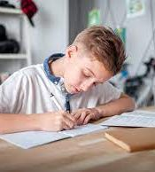

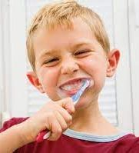
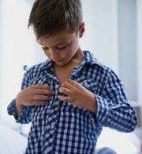

6- Aşağıdaki paragrafı okuyarak ifadelerin karşısına True (doğru) ya da False (yanlış) yazınız. (12 p)

Hi, I am Buse. I am 10 years old and I am a student. I go to secondary school. Here is my daily routine. I get up at 7.30 in the morning. I wash my hands and face. I have breakfast at 7.45 with my family. I go to school at 8:15. I go to school by bus.My school starts at 8.30. My favorite school subjet is science. I have lunch in the canteen at school. My school finishes at 14.30. I get back home at 14.45. I do my homework between 16.00 and 19.00 o’clock. We have dinner at 19.30. I read a book after dinner and I go to bed at 22.30

1-Buse is 11 years old. ____________
2-Buse has lunch at school ____________
3-Buse loves maths at school ____________
4-Buse goes to school by bus ____________
5-Buse plays computer game after dinner ____________
6-Buse goes to bed at half past twenty-two ___

