....................... ACADEMIC YEAR ................ SECONDARY SCHOOL 5th GRADERS 1st TERM 2ndENGLISH WRITTEN EXAM
5
Name - Surname:…………………………… Class / No:………… MARK:…………/ 100
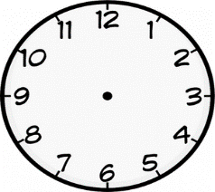
- Match the sentences with the clocks below.(2x5=10 Pts)
1 2. 3. 4. 5.

12:30 10:00 07:10 06:15 5:45
(…2……) It is ten o’clock. (…5…….) It is a quarter to six. (…1…..) It is half past twelve.
(…3……) It is ten past seven. (…6……) It is a quarter past six.
- Match the questions with the answers. (2x5=10 Pts)https://www.sorubak.com

- Do you like playing hopscotch? ( 5 )Yes, I can.
- What do you do in the afternoons? ( 3 )Yes, she does.
- Does she like playing keepy uppy? ( 2 )I have lunch in the afternoons.
- What time do you get up? ( 1 )No, I don’t.
- Can you play checkers? ( 4 )At 7:30.

C. Complete the phrases and match them with the pictures. (1x10=10 Pts)
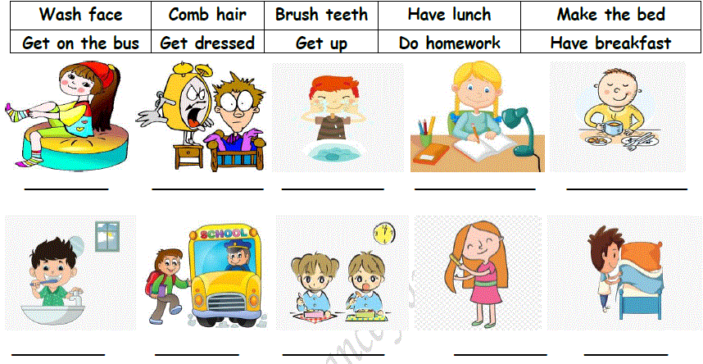
D. Match the phrases. ( 1x6=6 Pts)
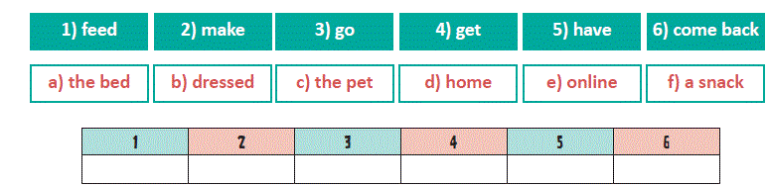

- According to the table, fill in the blanks with “CAN “, “CAN’T (2x10=20 Pts)
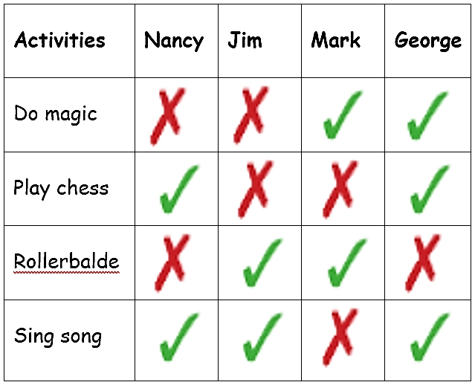
- Nancy………………………rollerblade.
- George…………………….sing song.
- Jim and Mark……………….play chess.
- George………………………rollerblade.
- Jim…………………….do magic.
- Nancy………………..sing song.
- Mark………………..sing song.
- Nancy and George……………..play chess.
- Jim………………rollerblade.
Rollerblade
10.Mark………………….do magic.

D. Write the Turkish meanings of the words.(1x6=6 Pts)E. Answer the Questions. ( 2x3=6 Pts)
Play blind man's buff
Play keepy-uppy
Play hopscotch
Turn right
Excuse me?
Library

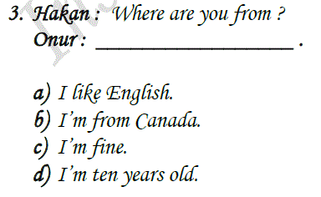
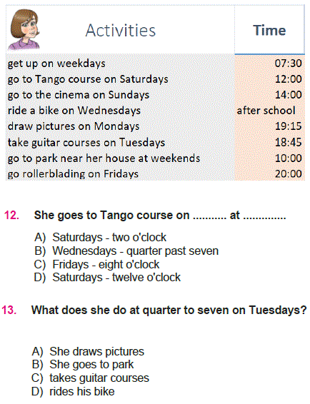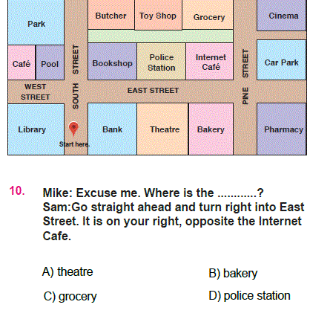

F. Match the phrases (1x6=6 Pts)
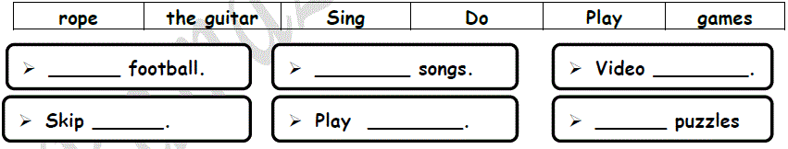
G. Fill in the blanks with the words given. (2x5=10 Pts)
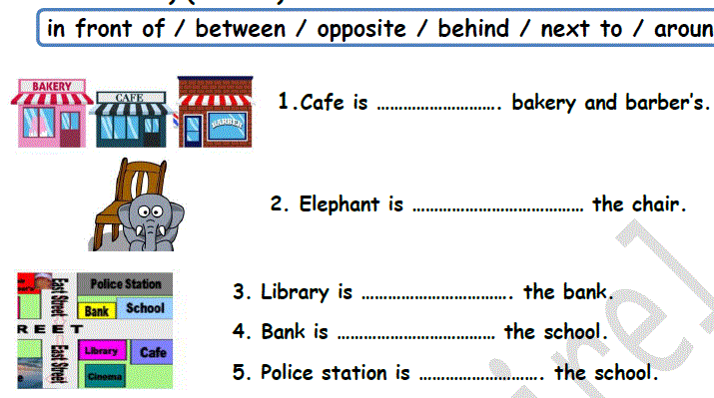

H. Match with the translations. (1x5=5 Pts)
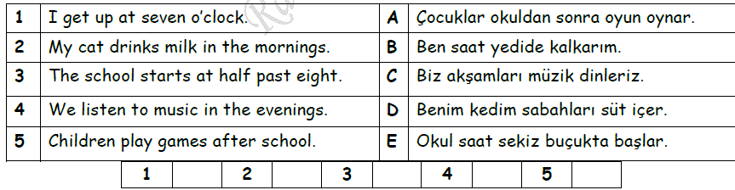
I. Write the numbers. (1x10=10 Pts)
Six + Seven=
Forty five + Seventeen=
Twenty two + Fifty two=
Ten + Thirty three=
Fifteen + Fifty=
Nine + Ninety=
Eleven + Seven=
Thirty four + Five=
Sixty + Fourteen=
Eighty one + Nine

