**……………….. EDUCATION YEAR**

**MAKBULE SÜLEYMAN ALKAN SECONDARY SCHOOL**

**2nd TERM 1st ENGLISH EXAM**

**5th GRADES – Elective Classes**

**A) Read the text and complete the sentences.( 30 pts.)**

Hello! I’m Alan.I’m 13 years old. My birthday is in December.

I like reading books and riding bike. I can play basketball,

but I can’t swim. I have a sister. Her name is Jennie.

She is 5 years old. Her birthday is in August.

She likes watching cartoon, but she doesn’t

like playing computer games. She can dance.

**1)** Alan is ............. years old.

**2)** He likes .................................................. and riding bike.

**3)** Alan can ........................................................., but he can’t swim.

**4)** His sister is ............... years old.

**5)** Her birthday is ............ August.

**6)**Jennie likes .............................. cartoon.

**B) Write the names of the games or activities.(24 pts.)**

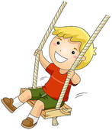

.......................... ................................... ................................ ...............................

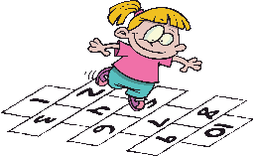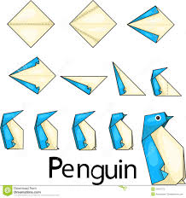

**C) Answer the questions about the movie.( 20 pts. )**

**ICE AGE**

1. **CHARACTERS: Ray Ramano,Dennis Leary**
2. **TYPE : Animation ,Adventure**
3. **Time: 15.30**
4. **1) What‘s on at cinema? …………………………………...........**
5. **2)Who are the main characters**?............................................
6. **3) What kind of movie is it?** .....................................................

**4) What time is the film?** ...........................................



**D) Answer.( 10 pts.)**cartoon

**1)** What type of movie do you like ? western

I like ..............................

**2)** What is your favourite party activity ?

My favourite activity is .................... **taking photos**



**dancing**



**eating cookies opening gifts**

**E) Write the names of the party materials.( 16 pts.)**



**cakehats**

**balloons**

**candles**

**gifts**

**clown**

.....................

.........................



**..**......................... ...................

**ELTeachers**

**F) Choose the best answer.( 14 pts.)**

[](http://images.google.com.tr/imgres?imgurl=http://justanothermobilemonday.com/Wordpress/wp-content/uploads/2007/01/WindowsLiveWriter/TAGImIt_F56D/MCj0244087000012.png&imgrefurl=http://www.squidoo.com/graywolves&usg=__bJlKyEVZteOBS_qc_Dhxd4Wf9ds=&h=390&w=640&sz=79&hl=tr&start=3&tbnid=ug5cXIiJGwZ03M:&tbnh=83&tbnw=137&prev=/images?q=playing+tag&gbv=2&hl=tr)****

**1)A :** What is your hobby? **a)b) c)**

**B :** I like **skipping rope**.

**2)** Backgammon,chess and checkers are ........................... games.

**a)** indoor **b)** board **c)** outdoor



**3)** Jane hates ............... swimming.

**a)** doing **b)**playing **c)** going



**4) Mary :** What’s the matter with her ? **a) b) c)**

**Sandy :** Oh ! She has **runny nose** ?



**5) John :** I have got a cold.

**Doctor :** You should .....................................

**a)** drinkmint and lemon tea **b)** use a plaster **c)** not carry heavy things.



**6)** Tom and Jerry is a .................. movie.

**a)** horror **b)** animation **c)** cartoon

**[](http://images.google.com.tr/imgres?imgurl=http://upload.wikimedia.org/wikipedia/tr/7/70/344px-Mickey_Mouse.svg.png&imgrefurl=http://paradies.wordpress.com/2008/11/16/&usg=__q_i1PvQYo7Jma6_8sJmZ87S8xF8=&h=395&w=344&sz=36&hl=tr&start=467&um=1&tbnid=mF5woWZakVAe9M:&tbnh=124&tbnw=108&prev=/images?q=%C3%A7izgi+film+karakterleri&start=450&ndsp=18&um=1&hl=tr&sa=N)**

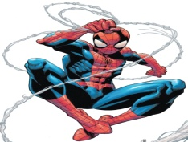

**Good luck !**

**7) Mike :** What is Spiderman like ?

**Gary :** I think he is............................**ELTeacher**

**Özlem Münire NARDALI**

**a)** brave **b)** liar **c)** cruel