Name:
Surname:
Class/Number:
KÖPRÜBAŞI PRIMARY SCHOOL 2ND TERM 1ST ENGLISH EXAM FOR 5TH GRADE

A. Find the months and write in the box.(Ayları bulup kutuya yazınız.) (12x2 pts)

1. 7.
2. 8.
3. 9.
4. 10.
5. 11.
6. 12.

J | A | N | U | A | R | Y | M | A | Y | S
G | U | T | S | M | A | R | C | H | E | E
J | P | T | U | G | P | A | S | E | D | P
U | L | R | E | F | R | U | T | Y | E | T
L | K | R | P | M | I | R | A | S | C | E
Y | Y | Z | A | S | L | B | A | W | E | M
P | A | Q | J | U | N | E | P | O | M | B
A | U | G | U | S | T | F | A | D | B | E
B | Q | B | S | O | C | T | O | B | E | R
N | O | V | E | M | B | E | R | T | R | U
B. Complete the missing parts. (Eksik bölümleri tamamlayınız.) (7x2 pts)

prepare

1
for permission from your parents.
2
send
buy
a guest list.
3
the invitation cards.
4
ask
make
the food.
5
the room.
6
buy
decorate
the beverages.
7
a present.

C. Unscramble the movies below. (Karışık olarak verilen film adlarını düzeltiniz.) (8x2 pts)

1)
omarnec
5)
ydmcoe
2)
mntrdcuoaye
6)
mniationa
3)
rrohro mfli
swen
7)
4)
acmulsia
tonorca
8)
D. Match the emotions with the pictures.(Surat ifadelerini resimlerle eşleştiriniz.) (2x5 pts)
5)
4)
3)
2)
1)

scary
exciting
boring
funny
interesting

E. Read the paragraph and answer the questions.(Paragrafı okuyunuz ve soruları cevaplayınız. (3x6 pts)

Hi! My name is Burak. I am eleven years old. I have got two sisters and a brother.I like my school and teachers very much. My favourite lesson is English .I like watching TV. My favourite movie type is horror film. My sister likes watching cartoon. I am ill now. I have got a bad cough .I can’t go to school. I should stay in bed and I should have a rest.

- Burak is eleven years old. TRUE FALSE
- Burak’s favourite lesson is Turkish. TRUE FALSE
- Burak’s favourite film type is horror film. TRUE FALSE
- Burak has got a bad backache. TRUE FALSE
- Burak should go to school. TRUE FALSE
- Burak’s sister likes watching romance. TRUE FALSE
F. Match the sentences with the pictures. (Resimlerle cümleleri eşleştiriniz.)(3x6 pts)

1) Murat doesn’t like playing chess. 4) Mehmet likes doing puzzle.
2) Merve likes reading book. 5) Ayşe likes drawing picture.
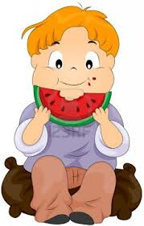
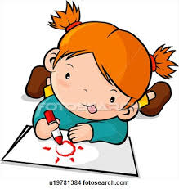
3) Mert likes eating fruit. 6) Zeynep doesn’t like eating fast food.
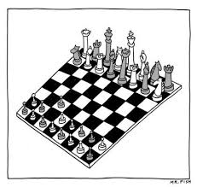
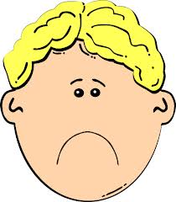
c)
b)
a)

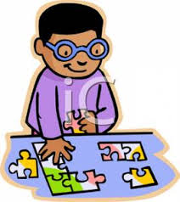
________________ _________________ _________________
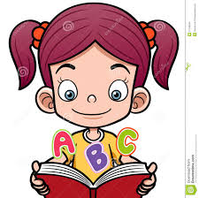
------------------------- ---------------------------- -----------------------------
f)
e)
d)

11)

