ISMAIL KARASU SCHOOL …………… ACADEMIC YEAR II. TERM I. EXAM
Name surname:……………………………………………………………… Number:…………………. Mark:………………….
A.Answer the questıons with simple present tense
1.(+) I …………………….. my car everyweek.Boşluğa hangi sözcük getirilmeli.
a) Washes b) washs c) wash d) washies
2. (+)Jack ……………………. book everyday .Boşluğa hangi sözcük getirilmeli.
a) read b) reads c) reading d)hiçbiri
3.(-)They …………………. have breakfast everymorning. Boşluğa hangi sözcük getirilmeli.
a) doesn’t b) aren’t c) isn’t d)don’t
4.(-) My mother …………………………. make pizza everynight. Boşluğa hangi sözcük getirilmeli.
a) doesn’t b)don’t c) aren’t d)isn’t
5. (?) …………… you teach English? Boşluğa hangi sözcük getirilmeli.
a) Does b) Are c) Do d) Is
6.(?) ……… She eat hamburger everyevening? Boşluğa hangi sözcük getirilmeli.
a) Is b) Are c) Do d) Does
7.Where do you play basketball? Cevabı hangisi olur.
a)I play on tv. b) I play basketball in park. c) I play piano d) I don’t plays basketball
8.When does Elif swim? Cevabı hangisi olur.
a)Elif swims everysunday. B) Elif swim in sea c) Elif swims in home d)Elif doesn’t swims
9. ……………… goes to school everyday. Boşluğa hangi sözcük getirilemez.
a) My sister b) He c) We d) She
10. …………..don’t drink milk. Boşluğa hangi sözcük getirilemez.
a) They b) Tom and Mike c) I d) Dog
B.Put the correct word under the pictures.
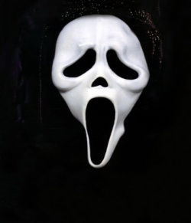
Comedy - Documentary - Horror - Cartoon - Western Film
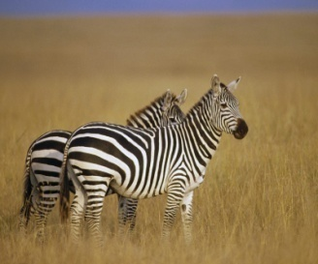
2.
3.
4.
5.
1.

C.Match.Write numbers in the blanks
1. -I have a high temperature(fever) go to the dentist.(……..)
2. – I have a headache. use a tissue.(……..)
3. – I have a backache . take a medicine (…….)
4. - I feel cold. Shouldn’t play basketball.(…….)
5. – I’m sneezing. take a painkiller(……..)
6. – I have a sore throat. see a doctor.(………)
7. – I have the flu. carry heavy things(……)
8. – My finger hurts(broken) take a blanket and stay in bed.(……)
9. – I have a broken leg. Shouldn’t drink cold water.(……)
10. – I have a toothache. have a rest.(……..)
D.
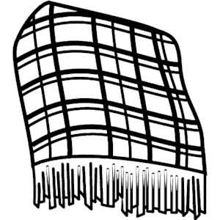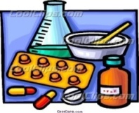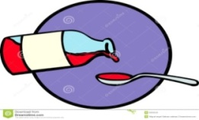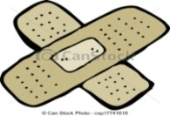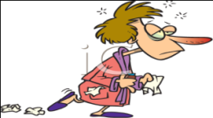

1.______________ 2. _______________ 3. ___________ 4. ____________ 5. ______________
Cough syrup / medicine / the flu / plaster / blanket

