…………… EDUCATION YEAR 2nd TERM 1st ENGLISH WRITTEN EXAM
FOR 5th GRADE OF 70. YIL HÜSEYİN ÖZTÜRK SECONDARY SCHOOL
Name : | Class : | Date : 24/04/20,,
Surname : | Number: | Mark :
- Tabloya göre cümlelerin karşısına “true” veya “false” yazınız.(8x2=16 pts.)
 | 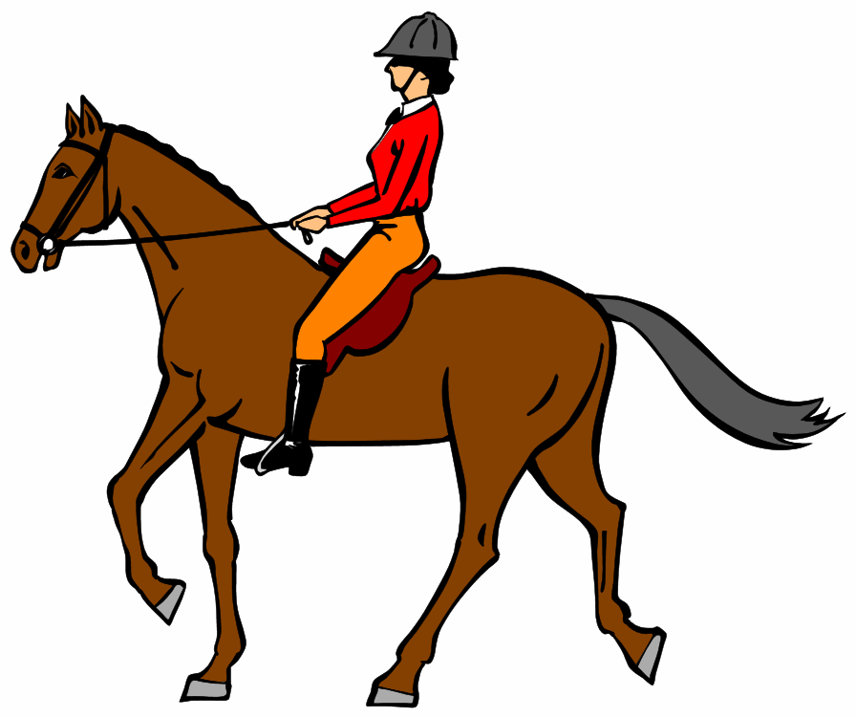 | 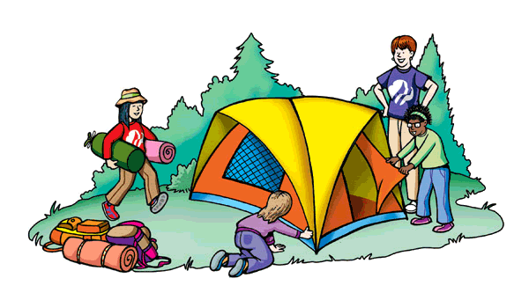 |  | 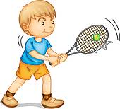
Jack
Daniel
Sue
Tom

= like = love = don’t like
- Tom loves riding a horse. _______ 5) Tom likes running. _______
- Sue doesn’t like running. _______ 6) Jack loves riding a horse. _______
- Jack loves camping. _______ 7) Sue likes playing tennis. _______
- Daniel doesn’t like playing tennis._______ 8) Daniel doesn’t like camping. _______
- Aşağıdaki ifadeleri doğru sütuna yazınız.(6x2=12 pts.)
Make a guest list – Send the invitation cards – Take an invitation card -
Ask permission to go to the party – Buy the beverages – Buy a gift –
THROW A PARTY | JOIN A PARTY
1.  2.  3. | 1.  2.  3.
- Aşağıdaki tavsiyelerle durumları eşleştiriniz.(5x2=10 pts.)
___ 1) I am tired. a) Let’s go to the theatre.
___ 2) I don’t have any money. b) How about going to the bank?
___ 3) It’s very hot. c) Let’s take an umbrella.
___ 4) It is rainy. d) How about having a rest?
___ 5) I feel bored. e) Let’s open the window.
- Aşağıdaki sorulara kısa cevaplar veriniz.(4x4=16 pts.)
- Can you do handspring? 3) Can Elif play tennis?
Yes, …………………. Yes, …………………….
No, ………………….. No, ……………………..
- Can he lift weights? 4) Can they ride a horse?
Yes, …………………. Yes, …………………….
No, ………………….. No, ……………………..
- Karışık olarak verilmiş cümleleri düzgün bir şekilde sıralayınız.(5x2=10 pts.)
- love / rope / skipping / I …………………………………………………….
- Berna / enjoy / doesn’t / swimming …………………………………………………….
- you / Do / jogging / hate ? ……………………………………………………..
- Canan / climbing / dislikes ……………………………………………………..
- They / love / don’t / skating …………………………………………………….
- Doğru seçeneği işaretleyiniz.(10x2=20 pts.)
- A: I’m hungry.
B: ______________ going to a restaurant?
- Let’s b) What time c) How about d) When
- David likes doing _________________.
- push up b) chin up c) sit up d) handspring
- Linda: I’m very bored today.
Sue: ____________________________.
- Let’s drink lemonade c) You should have a rest
- How about going to the cinema? d) I’m sorry, I can’t
- Birds ____________ fly but they ________________ run fast.
- can’t / can b) can / can c) can’t / can’t d) can / can’t
- Seçeneklerden hangisi diğer ifadelerden farklıdır?
- Bye. b) Take care. c) See you. d) Welcome.
- A: ______________ is the art class?
B: It is ______ seven o’clock.
- When / in b) What time / at c) Where / on d) How / at
- Mark: When is your birthday?
Sam: ___________________.
- It is at home c) It is on 13 August
- I like birthday parties d) I am ten years old
- There are _______________ under the tree.
- presents b) candles c) clowns d) invitation cards
- A: What ________ Eda ____________?
B: She ___________ some money.
- do / needs / needs c) do / need / needs
- does / need / needs d) does / need / need
- Let’s watch tv.
Seçeneklerden hangisi yukarıdaki öneriyi reddetmektedir?
- That sounds great. c) Sorry. I must study.
- It’s a good idea. d) OK. I like watching TV.
- Aşağıdaki kelimelerin Türkçe anlamlarını yazınız.(8x2=16 pts.)
- You are welcome: 5) June:
- cycling: 6) birthday:
- skiing: 7) chin up:
- beverages: 8) palm tree:

