- Kutuda verilen sözcüklerle ifadeleri eşleştirin.
*Romantic * Interesting * Boring * Exciting * Funny * Scary

1.......................... 2…………………… 3…………………….. 4…………………… 5…………………………. 6………………………………
- Aşağıda verilen mevsimlerin ait olduğu ayları yazın.
*January *February *March *April *May *June *July *August *September *October *November * December
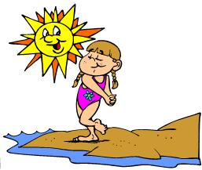
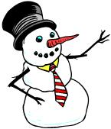
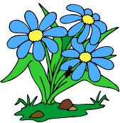

1.___________ 1. _____________ 1.____________ 1. ___________
2.___________ 2. _____________ 2. ___________ 2. ____________
3. ___________ 3._____________ 3.____________ 3. _____________
C) Boşlukları kutudan seçerek uygun şekilde doldurun.
* funny *boring * horror * exciting

- I am really frightened when I watch ______________ film.
- I like cartoons because I think they are _______________.
- I don’t like romantic films. I think they are ________________.
- I like adventure films because they are ______________.
- Zıt(karşıt) anlamlı sıfatları kutudan seçerek yazın.

* Fast *cold * hot *Slow * Fat * Thin * Clean * Dirty * Old * Young * Big * Small

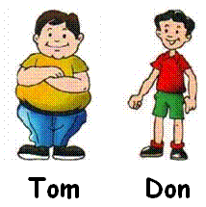
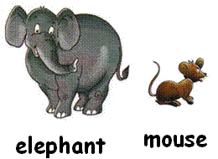
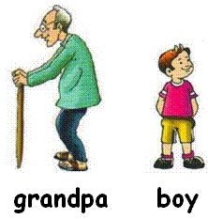

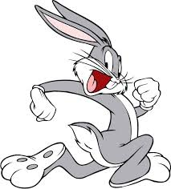
1.………………. X ……………... 2…………… X …..………… 3. ………………. X ………………..... 4………………..X…………….…
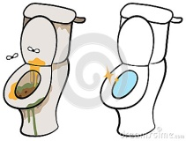
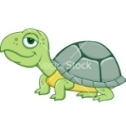

5........................ X …………………… 6. ………………………… X ………………………….

E)Boşlukları WHEN - WHAT - WHERE - WHY - WHAT TIME - WHO ile doldurun.
- ………………………… old are you? - I’m 12 years old.
- ………………………… is your birthday? - It is on 7th July.
- ………………………… is your name? - My name is Linda.
- ………………………… are you from? - I’m from England.
- ………………………… is your party? - It is at 3 o’clock.
- ………………………… is your English teacher? - She is Ayşegül KOÇER.

F)Doğru Seçeneği işaretleyin.
1. I ……… watching documentary but I ……… like watching romantic film. A) can / can’t B) like / don’t like C) like / doesn’t like D) can/ like
2. - Do you like watching TV? - …………,…………….
A) Yes, I do B) No, I don’t C) Yes, I can D) No I can’t
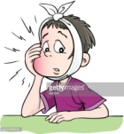
3.What is the matter with you? - I have got a ……………….
A) flu B) cough C) toothache D) stomachache
4.
I have got a backache.

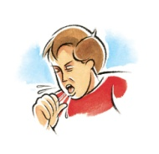
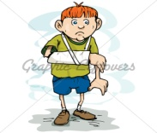
Verilen cümleyi ifade eden görsel hangisidir?
A) B)

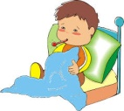
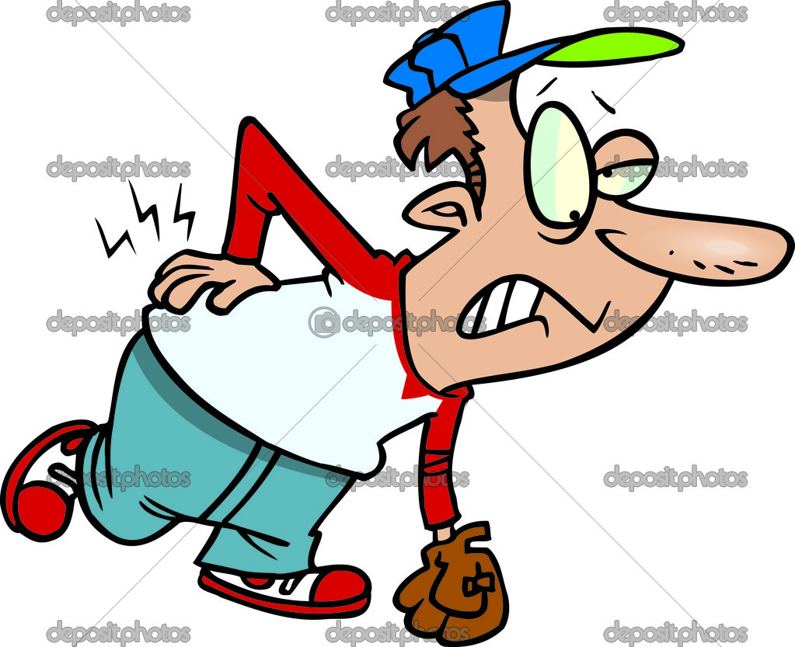
C) D)

- I have got a flu. What should I do?
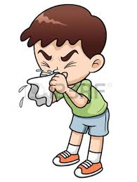
- You should have a rest.
- You should eat ice cream.
- You should play football.
- You should go to school.

- It is my 12th birthday party. I’m very excited.
Would you like to come to my party?

- Great! I would love to!
- What is your name?
- Do you like presents?
- What do you like?

- I need some ………… for the party.
- Guests
- Drinks
- Food
- Balloons
I have a birthday party on TUESDAY. Please come to my party!
Date: 16th June.
Place: Garden Cafe
Time: 14:00 p.m

- Where is the party?
- at home C) at school
- in the garden D) in Garden Cafe

- What time is the party?
- It is on Tuesday. C) It is on 16th June.
- It is in the garden. D) It is at 14:00.

- When is the party?
- On 12th March C) On 23th June
- On 16th June D) On 14: p.m

- Which is NOT for a party?
- Candles C) Gifts
- Invitation card D) blanket

- I like watching cartoons. I think they are …….
- Scaring C) Funny
- Interesting D) Boring

- Which one is DIFFERENT?
- February C) Autumn
- Winter D) Summer

- Which one is DIFFERENT?
- Wednesday C) April
- August D) December

- Which is WRONG?
- on 2st May C) on 3rd November
- on 13th June D) on 30th April

- Which is DIFFERENT?
- Horror film C) News
- Invitation card D) Animation

- I feel frightened in ……………….
- News C) Cartoon
- Cowboy film D) Horror film

