DOĞA COLLEGE SECONDARY SCHOOL 2. DÖNEM 1.EXAM
AD : SINIF: NOT:
SOYAD: NUMARA:

1-AŞAĞIDAKİ KELİMELERİN TÜRKÇESİNİ YAZINIZ.
HAİR: EYEBROW:
NOSE: EYELASHES:
CHEEK: LİP:
SHİN: TONGUE:
FOREHEAD: TEETH:
EAR: BACK:
MOUTH: STOMACH:
KNEE: TOE:
FEET: WAİST:
FİNGER: SHOULDER:
HAND:
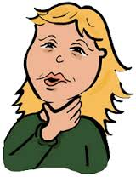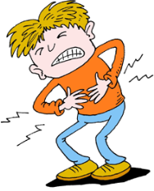
………………….. …………………………….
2-DİYOLOĞA GÖRE BOŞLUKLARI DOLDURUNUZ. B KİŞİSİNİN SORUNU NEDİR?
A:WHAT’S THE MATTER WİTH YOU? ………………………..
B: I’VE GOT TEMPERATURE.
A:GET WELL SOON. HASTALARA SORULAN SORU KALIBI NEDİR.
B: THANK YOU. ………………………………

3-AŞAĞIDAKİ SORULARI CEVAPLAYINIZ.
AŞAĞIDAKİLERDEN HANGİSİ YALNIŞTIR?
A)HEADACHE B)BRUİSEE C)TOOTHACHE D) BROKEN ARM
4-YANDAKİ RESİMİN ANLAMI ‘’ ATEŞ ‘’ İSE AŞAĞIDAKİLERDEN HANGİSİDİR?
- BROKEN ARM B)FEVER C) COUGH D) BLACK EYE

DİYOLOĞA GÖRE TAMAMLAYINIZ. B KİŞİSİNİN HASTALIĞI NEDİR?
A: WHAT’S THE MATTER WİTH YOU ? ……………………………..
B:I’M İLL.I’VE GOT RUNNY NOSE .
A: YOU SHOULD SEE A DOCTOR.
B:OK.THANK YOU. A KİŞİSİNİN 5.CÜMLESİNİN ANLAMI NEDİR?
A:GET BATTER SOON. …………………………………
B:THANKS.
A: YOU’RE WELCOME.
A KİŞİSİ B KİŞİSİNE NE ÖNERİYOR?
…………………………………….

5-AŞAĞIDAKİLERİN ANLAMINI YAZINIZ.
TİRED: GREAT:
ANGRY: DİZZY:
HOT: BAD:
COLD: SLEEPY:
FRİGHTENED: NERVOUS:
HAPPY: WONDERFULL:
SAD:
EXCİTED:
CURİOUS:

6-AŞAĞIDAKİLERİN ANLAMINI YAZINIZ.
CARTOON: KOVBOY:
ANİMATİON: MÜZİKAL:
CRİME: BELGESEL:
ROMANTİC: COMEDY:
HORROR: HİSTORİCAL:
BİLİM KURGU: ADVENTURE:

- Write the movie types under the pictures (5*3=15 points)

musical | romantic | cartoon | comedy | horror

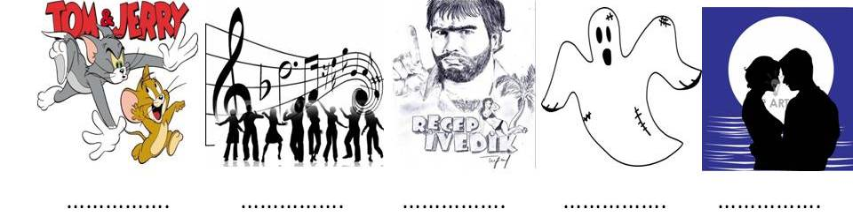
7-SORULARI CEVAPLANDIRINIZ
FETİH 1453 İS A HİSTORİCAL FİLM.
It’s about war.
TRANSFORMENS İS A SCİENCE FİCTİON FİLM.
……………………………………………….
ANİMAL NATİON İS A DOCUMENTARY.
…………………………………………..
DÜĞÜN DERNEK İS A COMEDY FİLM. MARRİAG –EVLİLİK
……………………………………..

8-AYLARI AŞAĞIYA YAZINIZ.
1-january 7-july
2-february 8-august
3-march 9-september
4-april 10-october
5-may 11-november
6-june 12-december
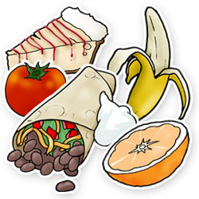

……………………. ……………… ………………….. …………………………………..

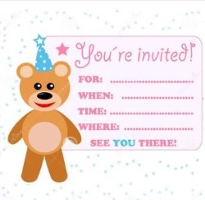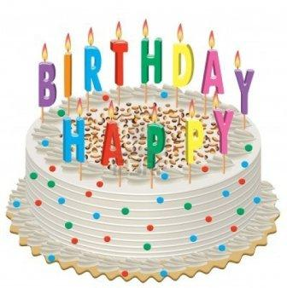
…………………….. …………………………… ………………… ………………………………………..

9- SORULARI CEVAPLAYIN.
WHEN İS YOUR BİRTHDAY? (31 OCAK)
…………………………………………..
WHEN İS YOUR BİRTHDAY?(KENDİNİZİNKİ)
…………………………………………………
WHAT’S YOUR FAVOURİTE MONTH?
…………………………………………………..
10-CAN I BUY A NEW T-SHİRT?
(+) …………………………..

11-MAY I ASK A QUESTİONS?
(-) …………………………..

12-CAN I BORROW YOUR …………?
(+) ………………………….

BOŞLUKLARI DOLDURUNUZ.MUST MUSTN’T

YOU ………………………. GO TO A DENTİST .YOU’RE A TOOTHACHE.I’M NOT İLL.I ……………….. SEE A DOCTOR.TOM İS A FAT. HE ………….. EAT FAST FOOD.MARY HAS AN EXAM .SHE …………… STUDY.IT’S RAİNİNG.I ………… TAKE MY UMBRELLA .IT’S COLD. I ……….. WEAR T-SHİRT.

ENGLİSH TEACHER
NİSAN ÖZTÜRK

