……………….. EDUCATION YEAR DOĞANYOL SECONDARY SCHOOL
5th GRADE 2nd TERM 2nd ENGLISH EXAMINATION
Name-Surname: Number:

- Match the words with pictures. (8x3 = 24 points)
Windsurfing | Swimming | Jogging | Horse riding | Fishing | Skating | Cycling | Diving

- 2. 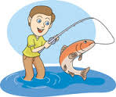 3. 4. 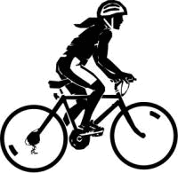
______________ ______________ ______________ ________________

5. 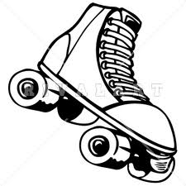 6.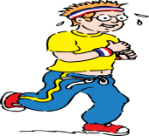 7.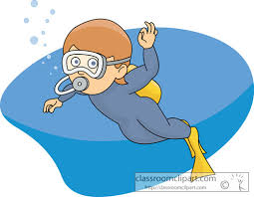 8.
_____________ ______________ _____________ _______________

- Match the given phrases with the related pictures. (6x3 = 18 points)

a. brush the dog c.water the flowers e. bath the dog
b. feed the cat d. take the dog for a walk f. take the to the vet

_____________________ ______________________ ____________________________
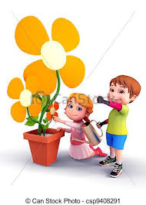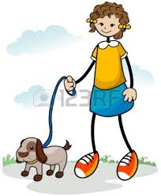
_____________________ _______________________ _________________________

- Read the text and write “True” or “False” according to the text. (6x3 = 18 points)

Hi! I’m Super Percy. I’m 12 years old. I live with my family. I’m very strong. I can lift weights. I like lifting heavy things. I can run fast but I can’t fly. I can climb high mountains and I love climbing. This is my friend Super Suzzy. She can do handspring. She can jump high. She is very strong and brave. She can stop trains with her hands.

- Super Percy is 14 years old. ____________
- Super Percy can run fast. ____________
- Super Suzzy can’t do handspring. ____________
- Super Percy and Super Suzzy aren’t strong. ____________
- Super Suzzy can’t jump. ____________
- Super Suzzy is brave. ____________

- Put the given animals into the correct category. (10x3 = 30 points)

Panda—zebra—sheep—chicken—lion—cow—snake—cat—elephant—horse

FARM ANIMALS | WILD ANIMALS

- Choose the correct answer. (5x2 = 10 points)

- Aşağıdakilerden hangisi “body part(vücudumuzun bölümü)’’ değildir?
- Hand C. Dog
- Stomach D.Nose

- Aşağıdakilerden hangisi “month(ay)” değildir?
- January C. March
- February D. Wednesday

- Aşağıdakilerden hangisi “day(gün)” değildir?

- Monday C. Sunday
- September D. Tuesday

- How old are you?

- I am at home.
- I am fourteen years old.
- It is red.
- My name is John.

- What is your favourite exercise?
- My name is Helen.
- I am 16 years old.
- My favourite exercise is hiking.
- I am from Bursa.

