**…………….. EDUCATION YEAR MEHMET AKİF ERSOY SECONDARY SCHOOL**

**2ndTERM 2nd EXAM FOR 5th GRADE**

**Name - Surname: Class:Number:**

**A.Aşağıda kutuda yazılı hayvan isimlerini uygun resmin altına yazınız.(10x2=20p)**

Giraffe Bird Cow  Goat  Bear  Turtle  Bee  Horse  Fox Butterfly

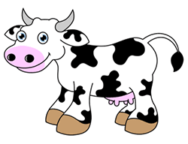

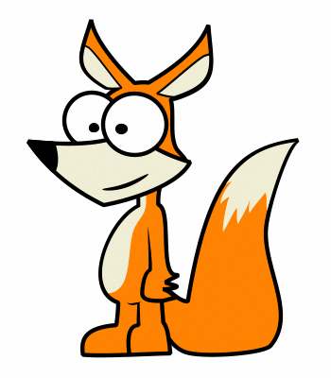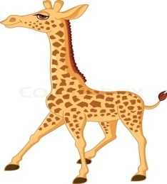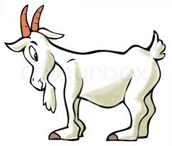

**B.Sporlarla uygun resmi eşleştiriniz.(8x2=16p)**

|  |  |  |  |
| --- | --- | --- | --- |
| Jogging | Skating | Sit-up | Windsurfing |
| Weight lifting | cycling | climbing | Push-up |

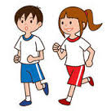

………………………. ………………………. ……………………… ……………………….

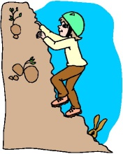

………………………. ………………………. ………………………... ………………………….

**C.Aşağıda verilen dört kelimeden farklı olanı yuvarlak içine alınız.(5x3=15p)**

1. Monday FridayJuneSaturday
2. AprilSeptemberJulyApple
3. CoughHairArmNose
4. January SpringSummerWinter
5. Autumn MonkeySnakeElephant

**D. Aşağıda okunuşları verilen sayıların yazılışlarını yanlarına yazınız.(7x2=14p)**

**1.** Two hundred and seventy five.

**2.** Six hundred and twenty. 

**3.** One hundred and seventeen. 

**4.** Three hundred and ninety one. 

**5.** Four hundred and eighty seven. 

**6.** One thousand.

**7.** Eight hundred and fifty nine. 

**E. Boşluklarıpresent progressive tense(şimdikizamana) uygun olarak doldurunuz.(10x2=20p)**

1. I ………………………………..…( brush) my teeth.(+)
2. She …………………………….….(walk).(+)
3. They ………………………………….(drink) milk.(+)
4. He ……………………………………( visit) the zoo.(+)
5. We ………………………………………(go) home. (+)
6. I ………………………….…….(eat) bananas.(-)
7. We………………………….…..(sleep).(-)
8. You ……………………………....(watch) tv.(-)
9. She……………………………….(play) tennis.(-)
10. He ………………………..…..( go) to school.(-)

**F. Aşağıdaki resimlerle verilen kelimeleri eşleştiriniz.(5x3=15p)**



**1-Halloween**

**2-Ramadan Festival**



**3-Children’s Day**

**4-Easter**



**5-Christmas**

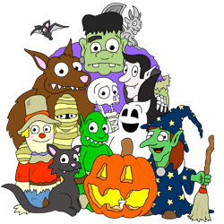

GOOD LUCK! Yasemin GÜNAYENGLISH TEACHER