**NAZLI ÖMER ÇETİN PRIMARY SCHOOL …………. 1ST TERM 2ND WRITTEN EXAM OF 7/A**

**NAME: SURNAME: NUMBER:**

**A)Put the words under the correct heading.(Aşağıdaki kelimeleri dogru kategoriye yerleştiriniz.)**

tall - lazy - rude - ugly - fat - stingy - shy - friendly - kind

gentle - handsome - jealous - thin - positive - romantic - artistic - clever

(17 points)

|  |  |
| --- | --- |
| Physical apperance | Personality |
| **……………………………………………………………..**  **……………………………………………………………**  **……………………………………………………………….**  **……………………………………………………………..**  **……………………………………………………………..**  **……………………………………………………………..** | **………………………………………………………………**  **…………………………………………………………..**  **…………………………………………………………..**  **…………………………………………………………..**  **…………………………………………………………..**  **……………………………………………………………** |

**B)Write the words in the blanks.*’’Mouse ,Keyboard,System Unit, Monitor,Speaker,Printer’’***

(2X6=12P)

Hi!I am here.I can help you.I can print documents,pictures,…

…………………….

Hi!I am here.I can help you.You can open and listen to music.

……………………..

Hi!I am here.I can help you.I have got numbers and letters.A,b,c,d,1,2,3,4.

……………………...

Hi!I am here.I can help you.I can open and close computer.

………………………….

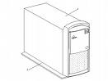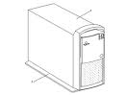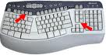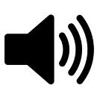

Hi!I am here.If you open me,you can speak with your friends on the msn…………………

Hello! i am an animal heheheh!!!!ı

………………………….

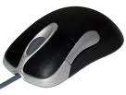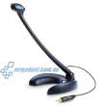

**C)CULTURAL HERITAGE ,NATURAL HERITAGE,INDUSTRIAL HERITAGE bu kelimeleri uygun kategoriye kutuların içine yerleştirin.(2X3=6P)**

………………………………………..

Mines,Factories,Science and Technology.

……………………………

Animals,plants,mountains,seas,

Deserts,rivers,

………………………………

Historic monuments,museums and customs.

**D)Write the sun signs( Burçları resimlerin altına yazın(aries.scorpio,leo,libra,pisces)(1X5=5 P)**

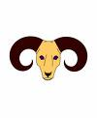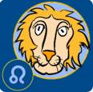

1)…………….  **2)………………… 3) ……………….. 4)……………… 5) …………………..**

**E)Make comparative sentences.(Parantez içindeki sıfatları kullanarak karşılaştırma cümleleri yapınız.)(2X10=20P)**

1)Ata Demirer is___________________________________than Beyaz (FAT)

2) Hakkari is________________________________________than İzmir(COLD)

3)Çağla Şikel is_______________________________________than Kibariye.(TALL)

4)Mathematics is ______________________________________than Turkish.(DIFFICULT)

5)Petek Dinçöz is _______________________________________than Yıldız Tilbe.(BEAUTIFUL))

6)Muhammed kaya is ___________________________________than Yunus(HANDSOME)

7)Susan is______________________________than Arzu (OLD)

8)The red sweater is_____________________than The blue sweater(EXPENSIVE)

9)Cities are__________________________________________than villages(BIG)

10) Villages are_______________________________________than Cities( DANGEROUS)

**F)Circle the correct one.**(2x20=40p)

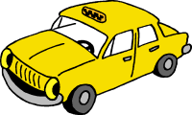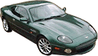

**The yellow car The black car**

**1)** a) The yellow car is more expensive than the red car. b) The yellow car is cheap then the red car

c) The red car is expensive than the yellow car.

d) The red car is more expensive than the yellow car.

Tom David

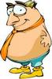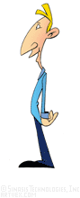

**2).**a) Tom is fat than David.

b) David is fatter than Tom.

c) David is more fat that Tom.

d)Tom is fatter than Davi

Erzurum Antalya

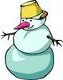

**3**). a) Erzurum is more cold than Antalya.

b) Antalya is more hot than Erzurum.

c) Erzurum is colder than Antalya.

d) Antalya is the hottest than Erzurum.

elephant mouse

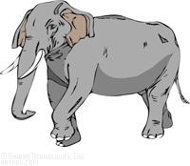

**4)** a) An elephant is the same as a mouse.

b) A mouse is than big an elephant.

c) An elephant is more big than a mouse.

d) A mouse is smaller than an elephant.

**5)He should eat fruit _________ vegetables.**

a)and b)but c)because d)so

**6**)**She should be on a diet__________she is very fat.**

a)and b)but c)because d)so

**7**)**A:_______________? B:I’m an Aries**

a)Are you interested in astrology?

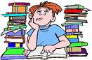

b)What is your horoscope?

c)What does your horoscope?

d)Do you beleive horoscopes?

**8) If you see a black cat, it ………….. you bad luck.**

a) will bring b) will brings c) brings d) bring

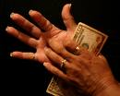

**9) İstanbul is more crowded than Ağrı.**

**There are……… people in İstanbul.**

**There are……… people in Ağrı.Boşlukları doldurun.**

a)many/few b)many/no c)any/no d)little/less

**10) … ………………………,you will have bad teeth.**

a)If you drink milk everyday,

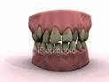

b)If you eat vegetables and fruits(apples,….),

c)If you eat alot of chocalate and sweets.

d)If you drink orange juice

**11)** )

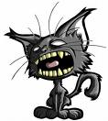

**I am hungry**.

………….

a)Shall we go to cinema? c)Shall we eat someting?

b)Shall we drink coffee? d)Shall we sleep?

**12)**

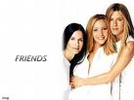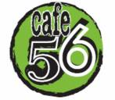

………….

a)Shall we play tenis? b)Shall we watch tv?

c)Shall we go to Paris? d)Shall we go to cafe?

**13)**

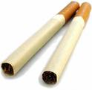

a)Smoking is more dangerous than Hamburger.

b)Smoking is more delicous than hamburger.

c)Smoking is better than hamburger.

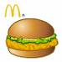

d)Hamburger is more dangerous than Smoking

**14)**

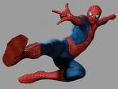

Yogi Spiderman

**Aşağıdakilerden hangisi söylenemez?**

a)Spiderman is stronger than Yogi.

b)Spiderman is faster than Yogi.

c)Spiderman is taller than Yogi.

d)Spiderman is weaker than Yogi.

**15)Naim süleymanoğlu is ………than Light Selami.**

a)stronger b) weaker

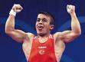

c)more strong d)more weak

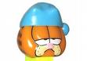

**16)Dialoğu tamamlayınız.**

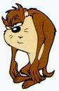

I am very tired,Garfield!

)

………

a)Shall we do homework ? b)Shall we dance?

c)Shall we go to bed and sleep ? d)Shall we play tennis?

**17) Resme uygun düşen ifade hangisidir**

a) you will be a successful student



b)you will be sad.

c) you will be a lazy student.

d)you will be a bad student.

**18)Resme uygun olan cümle hangisidir?**

a)If you see a black cat, you will be unlucky

b)If you jump over a baby,he will be short

c)If you drink cold water, you will be ill.

d)If you itch your palm,you will get money.

**19)If you always do sports,…………..**

a) you will be ill.

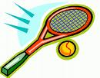

b)you will be fat and ugly.

c)you will be bored and tired.

d)you will be fit,slim,healty and dynamic



**20)**



**I can't buy this car. It is………………to buy it.**

A) Too new B) New enough

C) Too expensive D) Expensive enough

**ÖMER UYANIK ENGLISH TEACHER good luck.**

