……. EDUCATION YEAR KILAVUZLU Ş.N.K SECONDARY SCHOOL
1ST TERM 2ND ENGLISH EXAM FOR 5TH GRADE
Name / Surname : Number: Class:
A.Complete the blanks for yourself. (10*2=20p)
Hello! My name is ……………….. I am a student at ………………….. Secondary School. I am ………….. years old. I am from …………. and I am …………….. I can speak ……….. and …………… My favourite class is …………….But I don’t like ………… and ………….

B. Complete the blanks with the correct places. (5*2=10p)

park- bakery – hospital – school-pharmacy

We go to the ................. to buy medicine.
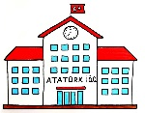

We go to the …………. to have classes.
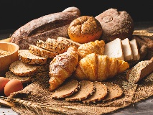

We go to the ……………… to buy bread.
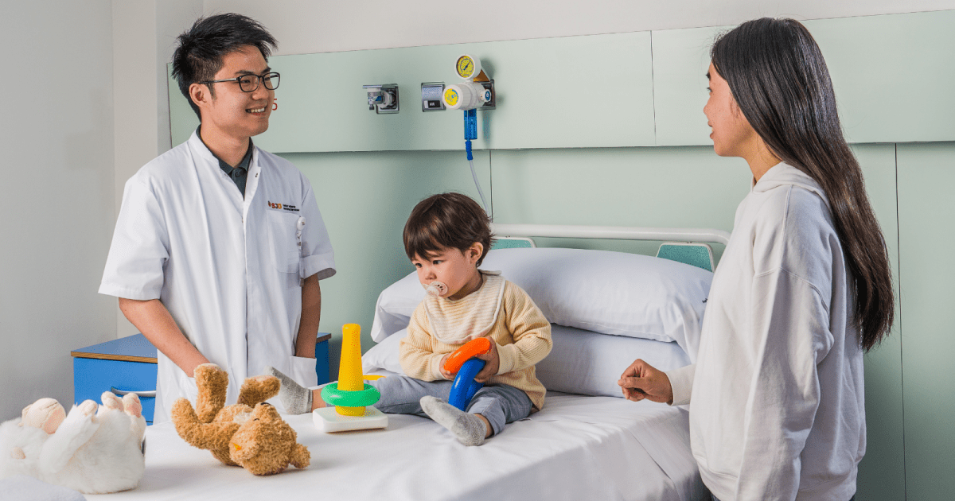

We go to the …………….. to see a doctor.
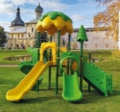

We go to the …………… to play games.

.Match the signs with the expressions.(5*2=10p)
go straight ahead | turn right | take the second right | turn left | take the second left

1.
2.
3.
4. 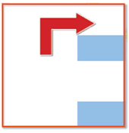
5.
D. Complete the games and hobbies with play, do or go. (10*1=10p)
………..fishing
……….. puzzle
……….. basketball
………... swimming
…………origami
………… to the cinema
………… table tennis
………… exercise
………… shopping
…………. Chinese Whisper
E. Answer the questions according to the table below. (10*2=20p)
Studenst | Likes <3 | Dislikes </3 | Ability | Inability
Kübra | swimming | fishing | do exercise | play chess
Selin | dancing | skipping rope | run fast | play basketball

1. What does Kübra like doing ? ..........
2. What does Selin dislike doing? ……
3. Does Kübra like fishing ? ………....
4. Does Selin like dancing ? ………....
5. Can Kübra play chess ? …………...
6. Can Selin run fast ? ……………........
7. Who can do exercise ? ……………....
8. How many students likes dancing ? …
9. Who can run fast ? …………………..
10. Can Selin play basketball ? ………..

G. Complete the daily routines.(8*1=8p)
(have / arrive / get / brush / wash / leave / wake)

…….. up
…….. hands and face
……… breakfast
………. teeth
………. dressed
………. home
………. on/off the school bus
………. at school

F. Write the numbers. ( 6*2=12p)
12 :…………………………..
15:…………………………..
20 :…………………………..
45:…………………………….
100:…………………………..
H.Write the words in the correct places. (6*2=12p)
(quarter past / o’clock / quarter to / past / to / half past)



 

