75.YIL SECONDARY SCHOOL 2ND TERM 1ST ENGLISH EXAM FOR 5TH GRADERS
NAME: SURNAME: NO:

A)RESİMLERİN SAYILARINI İLGİLİ YAZININ KARŞISINA YAZIN. 18 PUAN
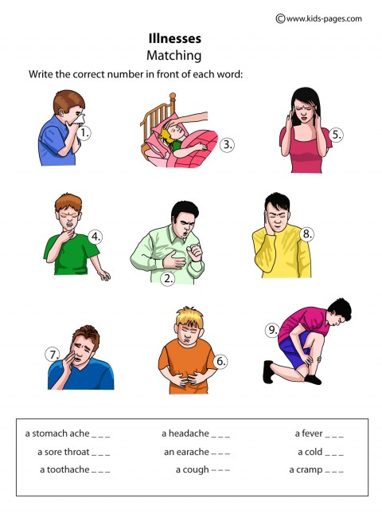

B:BOŞLUKLARI ( IN ,ON .AT ) İLE TAMAMLAYIN. 16 PUAN
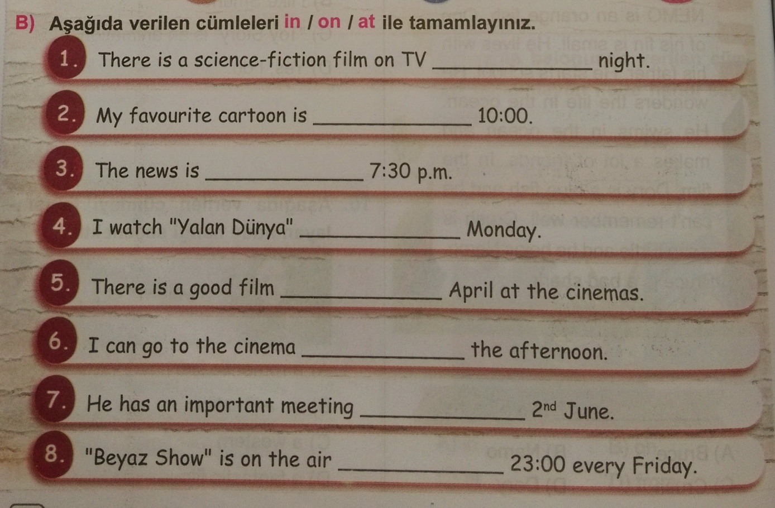
C:AŞAĞIDAKİ KELİMELERİ TÜRKÇELERİYLE EŞLEŞTİRİN. 10 PUAN
( )A:FANCY DRESS PARTY 1:DOĞUMGÜNÜ PARTİSİ
( )B:GARDEN PARTY 2:MEZUNİYET PARTİSİ
( )C:BIRTHDAY PARTY 3:KOSTÜM PARTİSİ
( )D:WEDDING PARTY 4:BAHÇE PARTİSİ
( )E:GRADUATION PARTY 5:DÜĞÜN PARTİSİ
D:FARKLI OLANI İŞARELEYİN. 10 PUAN
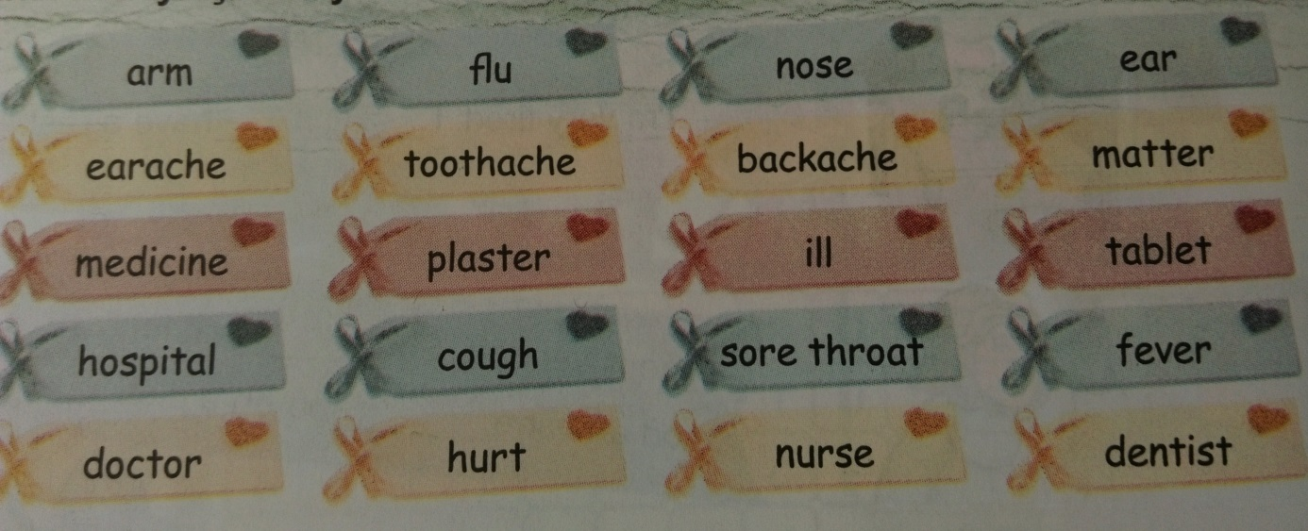
E: KUTU İÇİNDEKİ KELİMELERİ KULLANARAK CÜMLELERE ÖNERİ YAZIN. 15 PUAN
take an aspirin
take a cold shower
go to the dentist
go to the doctor
drink tea with honey

1)A: I have got a tooth ache.2) A: I have got a head ache
B:……………………………… B: ……………………………………....
3) A: I have got a fever. 4) A: I have got a cough.
B: ………………………………….. B: ………………………………………
5) A: I have got a ear ache. B:………………………………..
F:FİLM TÜRLERİNDEN BEŞ TANESİNİN İSMİNİ YAZINIZ.10 PUAN
1............................................... 2................................................... 3...................................................
4........................................................ 5.......................................................
G:AŞAĞIDAKİ KELİMELERİ RESİMLERİN ALTINA YERLEŞTİRİNİZ.21 PUAN

İNVİTATİON CARD , PRESENT , BALLOON , BEVERAGES , CAKE , CLOWN , CANDLE

............................../............................./......................................./............................/...............................
........................................../........................................../

