**2013-2014 ACADEMIC YEAR 80.YIL SECONDARY SCHOOL 2ND TERM 1ST WRITTEN EXAM OF ENGLISH LESSON FOR 5TH GRADES**

**Name& Surname: Class: 5/ Number: MARK:**

***A)Soruları cevaplayınız.(5\*3:15p)***

***1)*What is your name?.................................................**

**2)How old are you?.....................................................**

**3)Where are you from?.................................................**

**4)What is your nationality?.............................................**

**5)When is your birthday?..............................................**

***B)Aşağıdaki film türlerini resimlerle eşleştiriniz.(5\*2:10p)***

**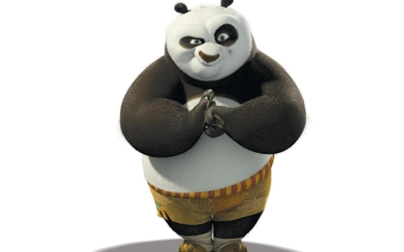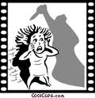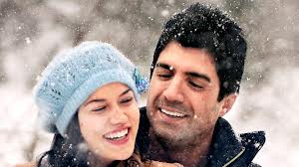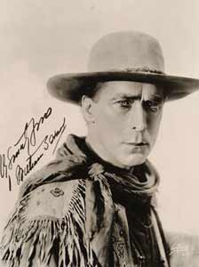 Horror film Romance Western film Animation film Comedy film**

**……………………….. ……………………. ………………………………………….. …………………………….. …………………………..**

***C)Mevsimlerle resimleri eşleştiriniz .(4\*1:4p)***

|  |
| --- |
| Autumn Summer Winter Spring |

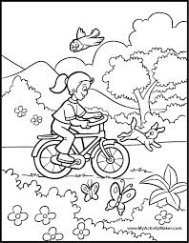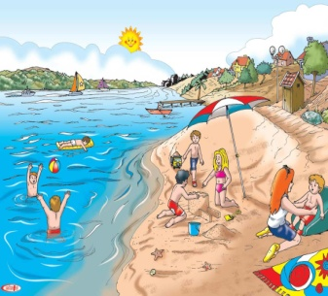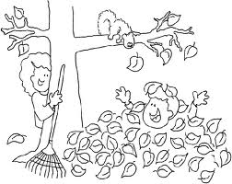

\_\_\_\_\_\_\_\_\_\_\_\_\_\_\_\_\_\_ \_\_\_\_\_\_\_\_\_\_\_\_\_\_\_\_\_\_ \_\_\_\_\_\_\_\_\_\_\_\_\_\_\_\_\_ \_\_\_\_\_\_\_\_\_\_\_\_\_\_\_\_

***D)Aşağıdaki soruları verilen ifadelere göre cevaplayınız.(5\*3:15p)***

1)Can you swim? 🡪 …………………………………………………………....

2)Can you take photo? 🡪 …………………………………………………………………………

3)Can he play chess? 🡪 ………………………………………………………………………..

 4)Can she play football ? 🡪 ……………………………………………………………….

 5)Can you run fast?🡪 **………………………………………………………..**

***E)Aşağıdaki kelimelerin Türkçe anlamlarını yazınız.(6\*2:12p)***

invitation card: interesting: illness:

guest: science fiction: medicine:

***F)Farklı olanın altını çiziniz(4\*2:8p)***

1. Monday – September – March – June
2. Adventure – Documentary – Comedy – watch
3. Sunday – Friday – Wednesday - April
4. doctor – toothache – fever– sore throat

|  |  |  |
| --- | --- | --- |
| ***G)Doğru olan cümleyi işaretleyiniz.(5\*3:15p)*** | | |
| **Boy** | **[grape](http://images.google.com.tr/imgres?imgurl=http://www.normanet.ne.jp/~tomoni/outdoor/grape.gif&imgrefurl=http://www.normanet.ne.jp/~tomoni/outdoor/outdoor.html&h=440&w=440&sz=7&hl=tr&start=5&tbnid=_9M1rRGxUN-IEM:&tbnh=127&tbnw=127&prev=/images?q=grape.gif++&gbv=2&svnum=10&hl=tr)** | **Jim likes apples.**  **Jim likes grapes.** |
| **[pc-girl_gif](http://images.google.com.tr/imgres?imgurl=http://www.edu-ctr.pref.kanagawa.jp/illustration/student/images/pc-girl_gif.gif&imgrefurl=http://www.edu-ctr.pref.kanagawa.jp/illustration/student/&h=576&w=583&sz=22&hl=tr&start=52&tbnid=PT8uI5MlxU9GdM:&tbnh=132&tbnw=134&prev=/images?q=girl.gif++&start=40&gbv=2&ndsp=20&svnum=10&hl=tr&sa=N)** | **[cake](http://images.google.com.tr/imgres?imgurl=http://leadwell.com/graphics/cake.gif&imgrefurl=http://leadwell.com/db/1/4/271/&h=173&w=192&sz=5&hl=tr&start=10&tbnid=ZooPlCLpuk_yuM:&tbnh=93&tbnw=103&prev=/images?q=cake.gif++&gbv=2&svnum=10&hl=tr)** | **Lisa doesn’t like cake.**  **Lisa doesn’t like hamburger.** |
| **[boy](http://images.google.com.tr/imgres?imgurl=http://members.fortunecity.com/arthurreeve/rugbycol/boy.gif&imgrefurl=http://members.fortunecity.com/arthurreeve/rugbycol.htm&h=1037&w=522&sz=25&hl=tr&start=5&tbnid=ztjVtjrFYcFDaM:&tbnh=150&tbnw=76&prev=/images?q=boy.gif++&gbv=2&svnum=10&hl=tr)** | **[cat](http://images.google.com.tr/imgres?imgurl=http://www.vetmed.auburn.edu/extras/styles/catnap/images/cat.gif&imgrefurl=http://www.vetmed.auburn.edu/extras/styles/catnap/images/&h=205&w=200&sz=10&hl=tr&start=7&tbnid=WazOUxLqcoX0kM:&tbnh=105&tbnw=102&prev=/images?q=cat.gif++&gbv=2&svnum=10&hl=tr)** | **Tom likes cats.**  **Tom likes dogs.** |
| **[girl](http://images.google.com.tr/imgres?imgurl=http://home.sprynet.com/~knduffy/girl.gif&imgrefurl=http://www.kevinduffy.net/kevin_duffy_cartoons_2.htm&h=400&w=246&sz=10&hl=tr&start=35&tbnid=DPI-2Fw32Am1FM:&tbnh=124&tbnw=76&prev=/images?q=girl.gif++&start=20&gbv=2&ndsp=20&svnum=10&hl=tr&sa=N)** | **[soup](http://images.google.com.tr/imgres?imgurl=http://www.chezmaya.com/carE/soup.gif&imgrefurl=http://www.chezmaya.com/carE/soup.htm&h=270&w=225&sz=10&hl=tr&start=5&tbnid=8P9Y4LMGKUUxXM:&tbnh=113&tbnw=94&prev=/images?q=soup.gif++&gbv=2&svnum=10&hl=tr)** | **Mary doesn’t like ice cream.**  **Mary doesn’t like soup.** |
| **[boy](http://images.google.com.tr/imgres?imgurl=http://www.firstvoiceskids.com/img-kids/boy.gif&imgrefurl=http://www.firstvoiceskids.com/&h=400&w=228&sz=18&hl=tr&start=1&tbnid=4R9PdJQrz5b21M:&tbnh=124&tbnw=71&prev=/images?q=boy.gif++&gbv=2&svnum=10&hl=tr)** | **[milk](http://images.google.com.tr/imgres?imgurl=http://clip-art-pictures.com/pics/food/milk.gif&imgrefurl=http://clip-art-pictures.com/milk.html&h=240&w=240&sz=6&hl=tr&start=12&tbnid=ya1OC0QKXtaeeM:&tbnh=110&tbnw=110&prev=/images?q=milk.gif&gbv=2&svnum=10&hl=tr)** | **Ahmet likes milk.**  **Ahmet likes tea.** |



***H)Soruları cevaplayınız.(3\*5:15p)***

- cough – flu – headache -

MCj03325780000[1]

**What’s the matter with you?**

**\_\_\_\_\_\_\_\_\_\_\_\_\_\_\_\_\_\_\_\_\_\_\_\_\_\_**

**What’s the matter with you?**

**\_\_\_\_\_\_\_\_\_\_\_\_\_\_\_\_\_\_\_\_\_\_\_\_\_\_**

**What’s the matter with you?**

**\_\_\_\_\_\_\_\_\_\_\_\_\_\_\_\_\_\_\_\_\_\_\_\_\_\_**



***I) Aşağıdaki kelimeleri resimlerle eşleştiriniz.(5\*1:5p)***

**balloons – birthday cake – beverage – gift - candle**

   

**.................. ………………… ………………… ….…………… ……..…… Hatice KOÇ**