…………….. EDUCATION YEAR OYMAKLISE CONDARY SCHOOL
6th GRADE 2nd TERM 2nd ENGLISH EXAM
Name-Surname: Number: Class:

- Read the paragraph and write ‘True’ or ‘False’ (5x2:10p)
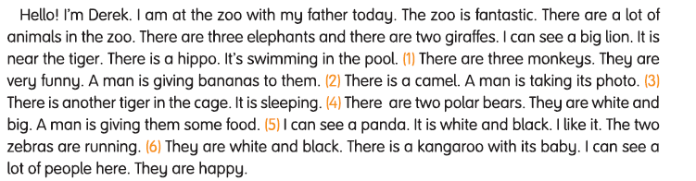

- I am at the zoo with my brother today. ________
- There are three elephants and there are four giraffes. _______
- There is a hippo. It’s not swimming in the pool. _______
- There are two polar bears. They are white and big. _______
- The two zebras are running. ______

- Write the names of the activities under the pictures. (10×3=30p)
Cycling -Skating - Chin-ups -Diving -Sit-up -Jogging -Climbing -Weight lifting -Hiking - Horse riding

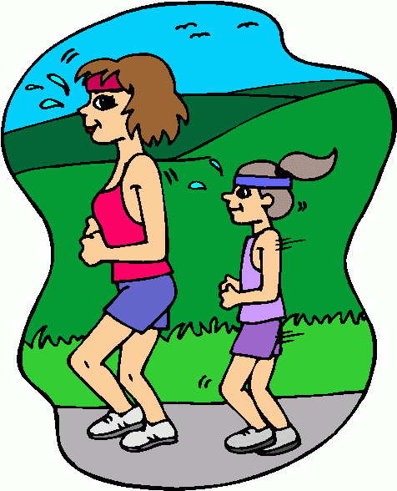
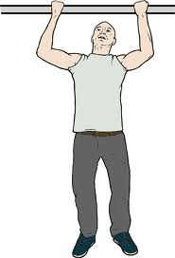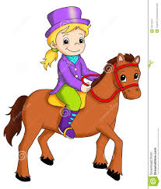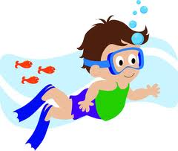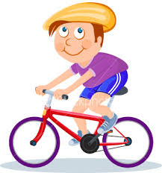

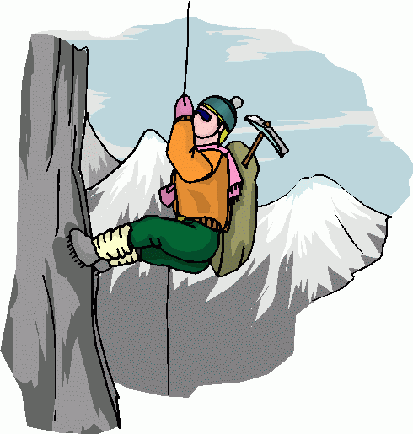
----------------------- --------------------------- ---------------------- -------------------------------- -------------------------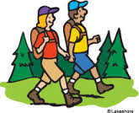  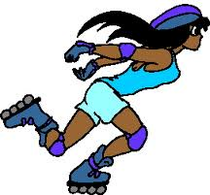 
--------------------- ----------------- ---------------- ----------------------- ---------------------
C) Fill in the blanks with “Let’s….”, “How about…” (5x3=15p)
1.A:……………………………….. drink milk. 2.A:……………………………… go to the park.
B: OK. B:That sounds great.
3.A:…………………………………. skipping rope? 4.A:……………………….. doing exercise?
B:Yeap,I’d love to. B:No,I’m bored.
5.A:………………………………... playing basketball?
B:Not now ,I’m tired.

D)Match the pictures with the words. (4×2=8p)

1. Pyjamas party 2. Birthday party

3. Fancy dress party 4. New Year’s party

E) Put the animals into the correct category. (10x1:10p)
-lion -cow -cat -elephant -tiger -horse -bear -sheep -duck -snake

Farm animals | Wild animals
F) Match the dates with the festivals in Turkey (4x3:12p)
a) 23rd ___ 1) Republic Day
b) 19th ___ 2) Children’s Day
c) 30th ___ 3) Victory Day
d) 29th___ 4) Youth and Sports Day

- Read the paragraph and fill in the chart (5x3=15 p)

His name is Kevin. He’s 11 years old. He is from Poland. His favourite sport is swimming. He practises on Tuesday and Friday.
Name
Age
Country
Sport
Practises on

