whale-cat-giraffe-hippo-dolphin-bird-shark-dog-elephant-tiger
- Put the animals into the correct place
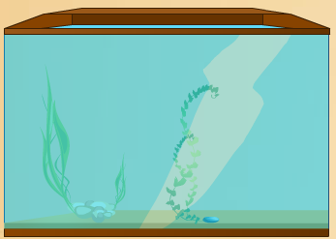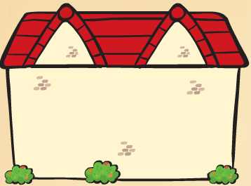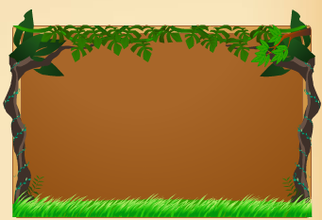
- Complete the sentences using Present ContinuousTense:
- My mother __________________ (cook) in the kitchen now.
- Laila and David _______________ (not play) in the garden.
- We ________________ (visit) the zoo at the moment.
- My cat ________________ (not sleep)
- The dogs ________________ (bark) outside.
- I ________________ (feed) the ducks.
- We ____________ (watch) a movie.
- ________ she ___________ (ride) a bike?
- What ______ you __________ (do) right now?
- They __________ (not run) .

- Write the names of festivals:

celebrate-sing-national-visit
- Complete the sentences with the words in thebox.
a. We ______________ Sacrifice Feast in Turkey.
b. We ______________ relatives on religious days.
c. On _______________ holidays,people go to parade.
d. We dance and ____________ songs.

- Match the pictures with the festival activities in the box:
wear costumes-decorate the tree-go to church-parade on the streets-Trick or Treat?-
cook a turkey-carve a pumpkin-light bonfires

Christmas
Thanksgiving
Easter
Halloween
- Write an activity for each festivals:

- Order the sentences:
- Cinco de Mayo-you-do-celebrate- How?
_________________________________

- costumes-Mexican-wear-We-traditional
_________________________________

