TERMİK SANTRAL SECONDARY SCHOOL
…………… ACADEMIC YEAR 5th Grade 2nd Term 2nd ENGLISH EXAM

Full Name: Number:

- Read the text and write “True” or “False” according to the text. (12 points)

Hi! I’m Super Percy. I’m 12 years old. I live with my family. I’m very strong. I can lift weights. I like lifting heavy things. I can run fast but I can’t fly. I can climb high mountains and I love climbing. This is my friend Super Suzzy. She can do handspring. She can jump high. She is very strong and brave. She can stop trains with her hands.

- Super Percy is 14 years old. ____________
- Super Percy can run fast. ____________
- Super Suzzy can’t do handspring. ____________
- Super Percy and Super Suzzy aren’t strong. ____________
- Super Suzzy can’t jump. ____________
- Super Suzzy is brave. ____________

- Put the given animals into the correct category. (10 points)

Panda—zebra—sheep—chicken—lion—cow—snake—cat—elephant—horse

FARM ANIMALS | WILD ANIMALS

- Write the names of the sports under the pictures (10 points)
Jogging | Skating | Swimming | Windsurfing | Baseball
Horse riding | cycling | climbing | fishing | basketball

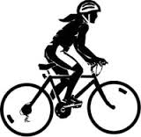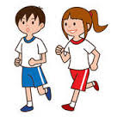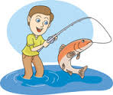
………………………. ………………………. ……………………… ………………………. ……………………….

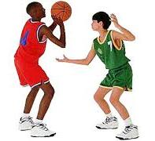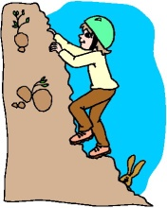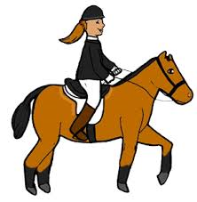
………………………. ………………………. ………………………. …………………… ……………………….

D.Fill in the blanks with “how about”, “shall we” or “let’s”. (10 pts )

- …………….…….. going to picnic this weekend?
- …………………... we play football?
- …………………... do hiking!
- …………………... make a cake!
- …………………... visiting our grandparents this weekend?
- …………………... swim!
- …………………... we eat a hamburger?
- …………………... we study History together?
- …………………... skipping a rope?
- …………………...doing yoga?

- Put the sentences into the correct category. (20 pts)
*It is not a good idea. *Shall we swim? *I can’t now. I must study. * That sounds great.

*How about swimming? *It is a good idea. *I am sorry. I can’t come. *Let’s swim!

*That sounds fun. *What about swimming?
SUGGESTIONS | REFUSING | ACCEPTING

E) Fill in the blanks with using Simple Continuous Tense (20 pts)

- I ………………………………..…( brush) my teeth.(+) 6.I ………………………….…….(eat) bananas.(-)
- She …………………………….….(walk).(+) 7. We………………………….…..(sleep).(-)
- They ………………………………….(drink) milk.(+) 8.You ……………………………....(watch) tv.(-)
- He ……………………………………( visit) the zoo.(+) 9.She……………………………….(play) tennis.(-)
- We ………………………………………(go) home. (+) 10.He ………………………..…..( go) to school.(-)
F.Match the given phrases with the related pictures. (18 pts)
a. brush the dog c. water the flowers e. bath the dog
b. feed the cat d. take the dog for a walk f. take the to the vet

