- How old are you?
- I am at home.
- I am fourteen years old.
- It is red.
- My name is John.

- What is your favourite movie?
- My name is Helin.
- I am from Hakkari.
- My favourite movie is cartoon.
- I like listening to music.

D) Aşağıdaki kelimeleri resimlerle eşleştiriniz.
(5 X 3 = 15P)
Happy | Angry | Sad
Scared | Sad | Sleepy

……………. ……………. …………….

……………. …………….
E) Farklı olan kelimeleri işaretleyiniz. (4 X 2,5 = 10P)
1. Comedy – Romance – Cartoon – Watch
2. Monday – Sunday – January – Tuesday
3. Toothache – Headache – Stomachache - Doctor.
4. Wednesday – September – October – November

- Aşağıdaki boşlukları (am – is – are ) ile uygun bir şekilde doldurunuz. (5 X 1 = 5P)

- I ……... from Yüksekova.
- You ……... very happy.
- My name ……... Ayşe.
- They ……... my friends.
- Ali and Ayşe ……... 12 years old.
- Aşağıdaki 4 soruyu cevaplayınız. (4 X 5 = 20P)

- A: What kind of movie do you like?
B: I like ……………. movies.
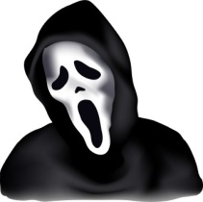
- Cartoon
- Musical
- Horror
- Action

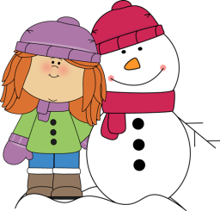
- “ I like playing snowball and making
snowman in …………….”
- Autumn
- Sunday
- January
- Winter

- A: What time is it ?
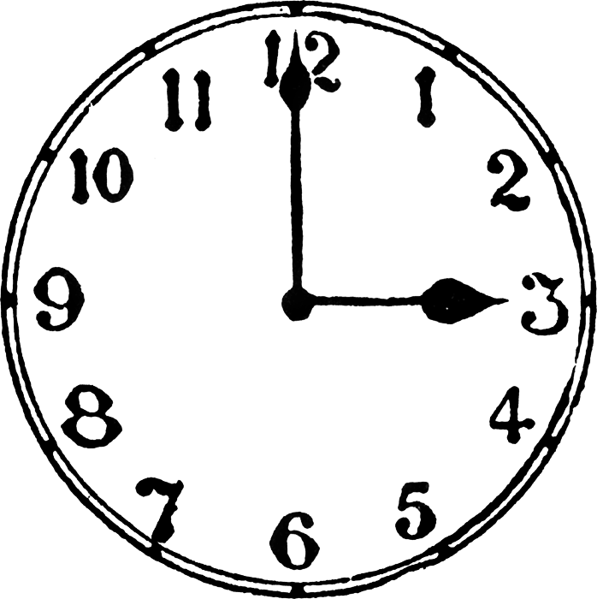
B: It is …………….

- It is quarter past twelve.
- It is quarter to twelve.
- It is half past twelve.
- It is three o’clock.

- Aşağıdaki boşluğu verilen tarihe gore doldurunuz.

“ My birthday is in ………………………… ” (11.02.2014)
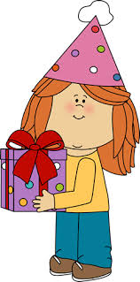
- November
- February
- September
- April

GOOD LUCK Samet SAYGI – ENGLISH TEACHER GOOD LUCK
Samet SAYGI – ENGLISH TEACHER

