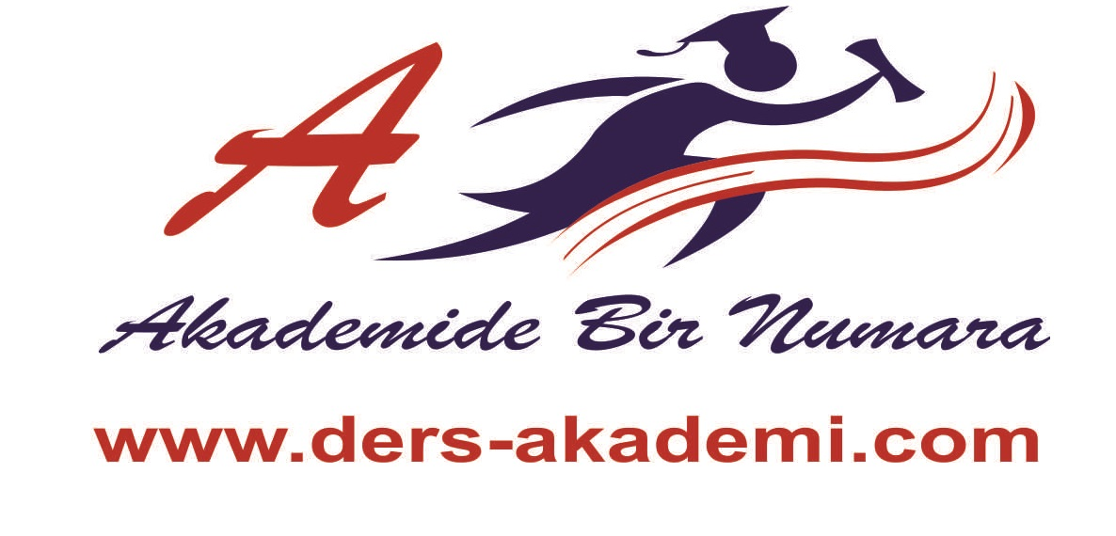
A) FILL IN THE BLANKS ( 3 x 4 = 12)
  - An elephant is ………………….. ( big) a mouse.
  - Hasan is ………………………( heavy ) Hüseyin.
  - The Kızılırmak is …………………( long ) The Yeşilırmak.
  - Hamburger is …………………………..( delicious ) pizza.
B ) CHOOSE THE CORRECT ANSWER ( 4 x 4 = 16 )
1. Today is ….... than tomorrow. 3. Erzurum is …………than Antalya.
a) gooder c) better a) hotter c) more large
b) more good d) good b) more beautiful d) colder

2. A horse is ……….. than a rabbit. 4. Smoking is ……… than snakes.
a) faster b) smaller a) more difficult b) easier
b) more handsome d) hotter c) more dangerous d) shorter

C) ANSWER THE QUESTIONS ( 3 x 2 = 6 )
1. Which one is more comfortable, a plane or a bicycle? ………………………………
2. Who is taller, Özlem BULUT or Gül KÖSEOĞLU? ……………………………..

D) MAKE SENTENCES ( 4 x 2 = 8 )
1. A car / A radio ( expensive ) ………………………………………………………………..
2. Mount Toros / Mount Ağrı ( high) …………………………………………………........

E ) SHOULD / SHOULDN’T ( 4 x 4 = 16 )
1. It is raining. You …………………. take an u umbrella.
2. We …………………… be quiet in the hospital.
3. You ………………………. smoke.
4. We ………………………throw rubbish on the ground.

F ) MATCH THEM ( 3 x 5 = 15 )
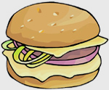
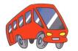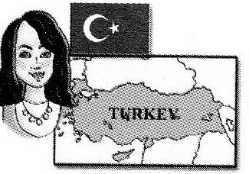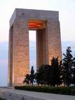

G) FIND THE DIFFERENT ( 3 x 3 = 9 )
1. a) recycle 2. a) fat 3) a) disadvantage x advantage
b) protect b) stingy b) refrigerator x fridge
c) waste c) lazy c) expensive x fast
d) save d) helpful d) international x local

H ) PUT THEM IN THE TABLE ( 3 x 4 = 12 )
Leo : You will have money problems.
Optimistic
Pessimistic
Virgo : You won’t get good mark from the exam.
Pisces : You will have fun.
Cancer : It will be an easy week.

I ) FILL IN THE BLANKS ( 2 x 3 = 6 )
1. Is there a bank ………. ..here?
2. Can you ………. me the way to park?
3. ……… straight on.

