AYŞE MÜZEYYEN TOZLUOĞLU İÖO 2008-2009 İNGİLİZCE
7. SINIFLAR 1. DÖNEM 2. ORTAK SINAV SORULARıDIR.

1. Kids love computers and Internet _____ than

anything else.

- much
- the furthest
- more
- the same as


2. Superman is _____ than Fred.


- stronger
- more expensive
- slower
- as easy as

3. Verilen eşleştirmelerden yanlış olanı hangisidir?

- global warming – küresel ısınma
- air pollution – hava kirliliği
- environment - mahalle
- recycle – geri dönüşüm


4. A camera is _____ a computer.

- the same as
- different from
- the most expensive
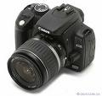
- bigger

5. Okan’s motorbike is ____ Cem’s motorbike.
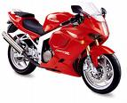
- the same as
- different from
- as careful as
- more difficult

6. soruyu verilen resme göre cevaplayınız.
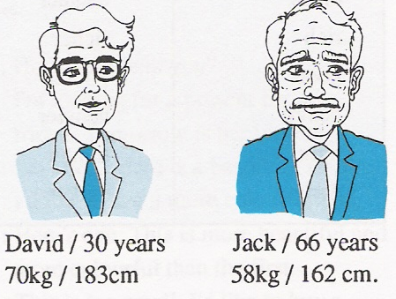

- David is older than Jack.
- Jack is taller than David.
- David is heavier than Jack.
- David is the same age as Jack.
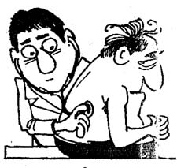

7. A: I am very ill, doctor.
B: ______

- You should go out and play.
- You should stay at home and rest.
- You should study English.
- You should paint your room.

8. Verilen sıftlardan hangisi yapı bakımından
diğerlerinden farklıdır?

good
bad
little
cheap

a) b) c) d)

9. “ I always go to work _____ .”
- by underground
- by bus
- by taxi
- on foot

10. “ The basketball match is ____ Saturday
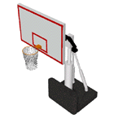
_____ seven o’clock.

- at - at
- on - at
- in - at
- at - in


11. Verilen hayvan isimlerinin ilk harfleri ile aşağıda verilen kelime tamamlanınca ortaya çıkan sıfat hangisidir?

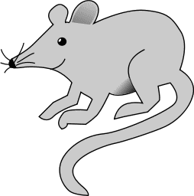


__ __ __ __ _Y_

- empty
- pretty
- messy
- hasty

12. Verilen resim hangi seçeneği hatırlatır?

- transportation
- accommodation
- air pollution
- monument

13. The weather is ____ in Summer than in

Winter.
- less
- worse
- better
- further

14. “ In the future cities will be more ____ .
There will be a lot of people in the world.”

- dirtier
- crowded
- healthier
- clean

15. A: ” _____ “
B: “She is really tall with short blonde hair
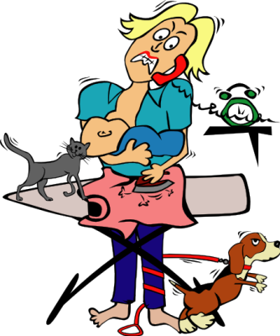
and she is very hardworking and generous.”

- Where does your mother live?
- How tall is your sister?
- What is your mother like?
- When does your mother work?

16. Resimler hangi seçenekte sırası ile verilmiştir?

- cycling – wrestling – weight lifting – martial arts
- martial arts – cycling – wrestling – weight lifting
- martial arts – cycling – weight lifting – wrestling
- wrestling – cycling – weight lifting – martial arts

17. A: “ _____ mushrooms are there?”
B: “ There are only a few .”
- How many
- Where
- When
- How much

18. “ I am as heavy as my sister.”

- Ben kız kardeşimden daha ağırım.
- Ben kız kardeşimden farklıyım.
- Kız kardeşim benden daha ağır.
- Ben kız kardeşim kadar ağırım.

19. Eşleştirmelerden hangisi yanlış verilmiştir.
- intelligent – ilginç
- important - önemli
- generous - cömert
- handsome - yakışıklı

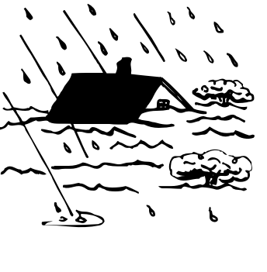
20. A: ” ______ “
B: “ It is windy and rainy.”

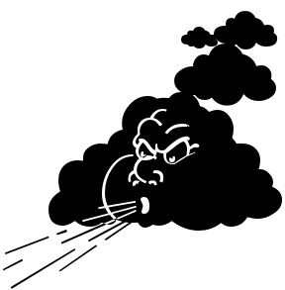
- What do you do?
- What is the weather like?
- When is your birthday?
- What is your sister like?

