ŞİRİNEVLER İLKÖĞRETİM OKULU 2008-2009 ÖĞRETİM YILI 1.DÖNEM 7.SINIFLAR 2. ORTAK İNGİLİZCE YAZILISIDIR.

AD-SOYAD:
SINIF-NUMARA:
A) Bilgisayarın parçalarını yazınız.(7x2=14 pts.)

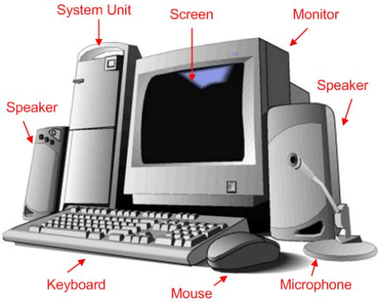

comfortablthan
  - more comfortable than
  - more comfortabler than
  - comfortabler than

B)Doğru seçeneği yuvarlak içine alınız.(19x4=76)

1.A: I can’t see the board when I sit at the back.
B: You _______sit in the front row.
a)can b)can’t c)should d)mustn’t
2.A:I have got a tootache.
B:You _________see a doctor.
a)must b)shouldn’t c)can d)mustn’t
3.I ___________study tonight.There is an exam tomorrow.
a)must b)should c)can d)shouldn’t
4.It looks like rain.You ___________take an umbrella.
a)can b)should c)mustn’t d)shouldn’t
5.A:I’m cold.
B:You_________put on your jacket.
a)can’t b)will c)should d)mustn’t
6)Football is________tennis.
a)popular more than b)the more popular
c)popular than d)more popular than
7)I’m ______my sister-she’s 190cm tall and I’m 170cm tall.
a)short b)shorter than
c)shorter d)than
8)Big supermarkets are________small groceries.
a)cheap than b)the more cheaper than
c)cheaper than d)cheap
9.Adana is ………………....... Konya.
a)far than b) further than

c)more far than d)farer
10.My camera is___________yours.It’s about 200 grams.
a)heavier than b)heavy
c)heavier d)more heavy than
11. Ağrı is ………………. than Muğla.
    - cold b) more cold
c) colder than d) colder
12.A plane is ……………………… a train.
a)comfortable than

b)more comfortable than

c)more comfortabler than

d) comfortabler than

13.America is___________Canada.

a)more large than b)more larger
c)larger than d)large than

14.My uncle is____________my father.
He is a millionare.
a)richer than b)rich
c)richer d)more richer
15.It’s ______than yesterday.Let’s not go out tonight.
a)worse b)good c)better d)bad
16.I need a ___________bag than this one.
a)more big b)bigger
c)bigger than d)big
17.playing computer games is ______________tidying my room.
a)interestinger than b)more interesting than
c)the more interesting d)interesting than
18.Rabbits are ____turtles. They have got really strong legs.
a)fast b)faster
c)faster than d)more faster than
19.my car is ____than brains.It’s also comfortable.
a)expensive b)more expensive
c)expensive d)expensively

C) Aşağıdaki kelimelerin türkçelerini yazın.(10X1=10)
recycle
rainforest
preserve
Global warming
environment
rubbish
climate
information
communicate
Search engine


