What is the environment? A) Fill in the blanks. (5x3p=15p)
ADI/SOYADI :
NUMARASI :
SINIFI :
There is a natural world around us. It’s the (1)……………… (Yandaki metinde boşlukları
People, animals and plant live in this world. aşağıda verilen kelimelerden uygun
Our environment is our heritage and we must preserve it. olanları ile doldurunuz)
What is heritage?
People get a lot of things from their past. They are very
environment
preserve
important things. That is our (2)……………….. Heritage passes from
one (3)………………………to the other generation. Every generation
generation
save
must (4)……………… and (5)…………………. the heritage for the next
heritage
generations.

- Answer the questions. (2x6p=12p)
(Yukarıdaki metinle ilgili aşağıdaki iki soruyu cevaplayınız)
- What is the natural world around us?
…………………………………………………………………………………………….
- What passes from one generation to the other generation?
…………………………………………………………………………………………….
- Describe the addresses with the patterns in the boxes. (2x6p=12p)
(Kutular içerisinde verilen kalıpları kullanarak adresleri tarif ediniz.)
Go straight on.
Turn left / right.
It’s on your left / right.
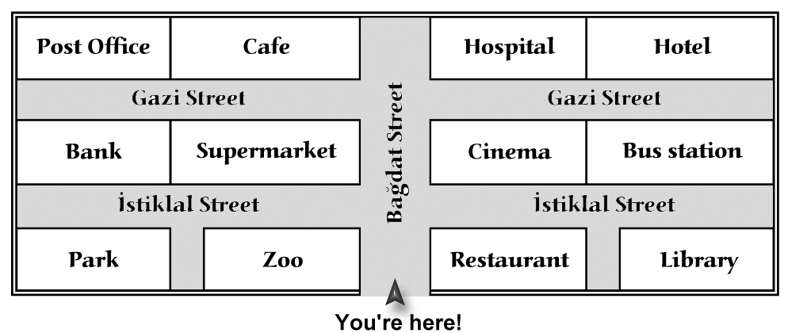
- If you want to go to the café, you will ……………………………….
………………………………………………………………………………………..…………………………………………………………………………………………..…
- If you want to go to the hotel, you will ……………………………..
………………………………………………………………………………………..…………………………………………………………………………………………..…
Buradasınız

- Fill in the blanks. (Boşlukları doldurunuz) (3x5p=15p)
- If he _____________ hard (study), he _____________ his exams. (pass)
- If you ________________ to your teacher (listen), you ____________ good marks. (get)
- Your mother ___________ you a cake (cook) if you ___________ her angry. (not/make)

- Fill in the blanks with “because”, “and” or “but”. (3x5p=15p)
(Boşlukları “because”, “and” ya da “but” ile doldurunuz)
- Old houses of Beypazarı are white ……………………. they usually have 2 or 3 floors.
- Silver jewellery is very famous in Beypazarı ……………………………. they are handmade.
- The streets are full of tourists …………………… they aren’t from different countries.

Haydarpaşa Station | Adapazarı Station | Eskişehir Station | Ankara Station
10:00 | 12:00 | 16:00 | 20:00
14:00 | 16:00 | 20:00 | 00:00
18:00 | 20:00 | 00:00 | 04:00

- Answer the questions according to the timetable. (3x5p=15p)
(Soruları yukarıda verilen tren çizelgesine gore cevaplayınız)
- What time does the first train leave Haydarpaşa?
…………………………………………………………………………………….. .
- What time does the 18:00 train from Haydarpaşa arrive at Eskişehir?
…………………………………………………………………………………….. .
- Is there a train from Adapazarı to Ankara at 18:00?
…………………………………………………………………………………….. .

- Fill in the blanks with “more”, “fewer” or “less”. (8x2p=16p)
(Boşlukları “more”, “fewer” ya da “less” ile doldurunuz)
More forests.
………….. rain.
n.
………. water.
……….. plants.
………. food.
Fewer forests.
……….. rain.
……….. water.
………. plants.
…………. food.


GOOD LUCK!
Ahmet Sinan KAPLAN

