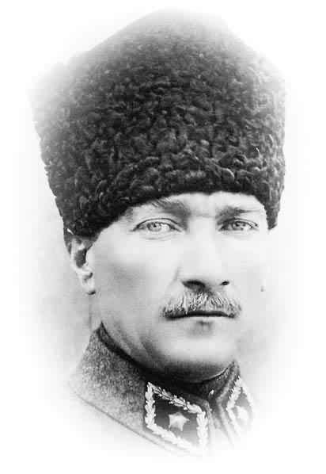
NAME : Date:
ATAM İZİNDEYİZ...
0…/….2010

SURNAME :
NUMBER :
CEVATPAŞA PRIMARY SCHOOL 2008-2009 ACADEMIC YEAR
FIRST TERM SEVENTH CLASSES SECOND WRITTEN ENGLISH EXAM

- Compare the pictures using the correct adjectives. ‘’4 pts ’’
(Resimleri doğru sıfatı kullanarak karşılaştırınız.)
Adjectives ; fast / expensive / short / beautiful / heavy / hot
1. 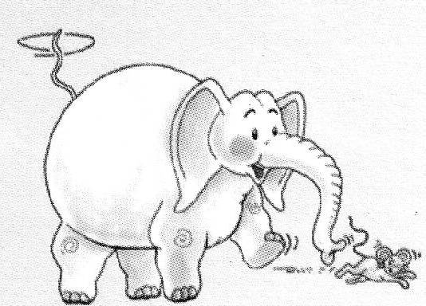  …………………………………………………………..
2.  (Mary) 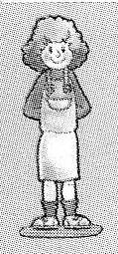 (Julia) ………………………………………………………………………………………
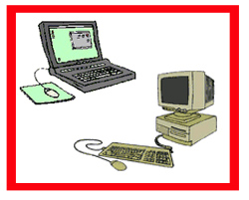

……………………………………………………………………………………….
4. AntalyaHakkari ………………………………………………………………………………………
5. 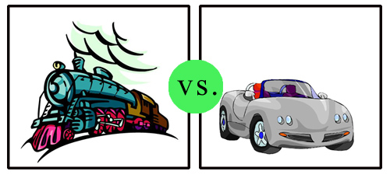 ……………………………………………………...
6.  Elizabeth Gloria ………………………………………………………………………………………

- Look at the pictures and answer the questions.(Resimlere bakıp sorulara cevap veriniz) ‘’4pts ’’
House A House B House C
(110.000 YTL) (40.000 YTL) (60.000 YTL)
(four bedrooms) (a bedroom) (two bedrooms)
(one years old) (two years old) (five years old)

1.Which is the cheapest house ? …………………………………………………………………………..
2.Which is the biggest one ? …………………………………………………………………………..
3.Which is the most expensive one ? …………………………………………………………………………..
4.Which is the oldest one ? …………………………………………………………………………..
5.Which is the most beautiful one ? …………………………………………………………………………..
- Complete the sentences using the comparatives or superlatives of adjectives. ‘’ 3 pts ’’
(Cümleleri sıfatların karşılaştırma ve üstünlük hallerini kullanarak tamamlayınız)
1.This problem ______________________ one in the book. (difficult)
2.Planes ________________________ buses. (comfortable)
3.Ağrı _________________________ Antalya. (cold)
4.Antalya _________________________ city in Turkey. (hot)
5.My homework _________________________ your homework. (good)
6.Everest _________________________ mountain in the world.(high)

D) Match the sentences. (Cümleleri eşleştiriniz) “ 3 pts ”
1.She can’t drink this coffee. (……..) a) They are too old.
2.We can’t answer these questions. (……..) b) It is too cold.
3.I can’t wear these trousers. (……..) c) It is too expensive.
4.He can’t buy this sports car. (……..) d) It is too hot
5.The children can’t play in the garden. (…….…) e) They are too difficult.

- Match the computer parts.(Bilgisayarın bölümlerini eşleştiriniz) ‘’ 2 pts ’’
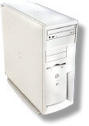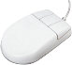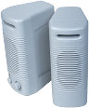

…………. ………… ……….. ………... ………

a) speakers b) CD c) monitor d) keyboard e) mouse

F) Choose the correct answer. (Doğru olan cevabı işaretleyiniz.) ‘’ 3 pts ’’
1.If you study hard , you __________ the exam.
a) pass b) will pass
2.They will go on a picnic if the weather ___________.
a) won’t rain b) doesn’t rain
3.There will be ________ forests in the future.
a) fewer b) less
4.Class A has 40 students. Class B has 30 students.
Class A has ________ students.
a) fewer b) more
5.A:Shall we watch television ?
B:__________________
- No, we don’t. b) I’m afraid, we can’t.
6.A:Shall we go shopping today?
B:___________________.
a) Yes, we do b) Yes , that’s a good idea



