MUALLİM CEVDET İLKÖĞRETİM OKULU
2nd Exam for 7th Grade Students
1st Term
Name: 1 December 2008
Surname: Time: 40 minutes
A. Choose the correct one (3x6=18 pts) Doğru şıkkı işaretle.

1. If I ……… well, I ……… to work.
a. feel / won’t go
b. don’t feel / will go
c. don’t feel / won’t go
d. will feel / don’t go
2. ……… a taxi, if you ……… late.
a. will take / are b. take / are
c. can take / were d. take / were
3.You can’t go out if you ……… your homework.
a. do b. will do
c. don’t do d. can do
4.If I ……… hard, I won’t be successful.
a. study b. will study
c. won’t study d. don’t study
5. If they study hard, they ……… the university exam.
a. pass b. will pass
c. can’t pass d. won’t pass
6. I ……… swimming, if it is cold.
a. can’t go b. will go
c. go d. doesn’t go

B.Choose the correct one (3x4 =12 pts)

1. “I’m hungry.”
a. Shall we go out?
b. Let’s go to the cinema.
c. Let’s not.
d. Shall we have dinner?
C. Circle the correct one (2x10=20 pts.) Doğru olanı daire içine al.
1. Our neighbours work / is working in their garden now.
2. The dog plays / is playing with a ball right now.
3. I never drink / am drinking coffee.
4. Mrs. Brown is reading / read a newspaper at the moment.
5. She usually wears / is wearing blue T-shirt but today she wears / is wearing a red one.
6. Be quiet! I am trying / try to solve the problem.
7. They usually are eating / eat broccoli and cabbage in winter.
8. Tom likes / is liking football very much. He often goes / is going to football matches on Sundays.

2. “I’m cold.”
a. Shall we go inside?
b. Let’s go out.
c. Let’s have breakfast.
d. Let’s eat outside.

3. “I’m bored.”
a. Shall we swim?
b. Let’s go to the cinema.
c. Shall we clean the house?
d. Shall we have lunch?

4. “I have an exam tomorrow.”
a. Let’s play computer games.
b. Shall we study?
c. Shall we help her?
d. Let’s go shopping?

D. Answer the questions (3x2=6 pts.) Soruları cevapla.
1. What will happen if we don’t have enough forests?
tourist attraction | environment | heritage | lay
preserve | rainforests | recycle | danger
2. What can people do on the Internet?

- Fill in the blanks with the correct words (3x8=24 pts.) (Boşluklara kutudaki uygun kelimeleri yerleştirin.)
1) We should put the old magazines in the wastepaper bin. Because people will …………………..them later.
2) ………………….. passes from one generation to the other generation.
3) If we don’t cut off trees to make paper, we can ………………….. the environment.
4) There is a natural world around us. It is the …………………..
5) Global problem is a big problem. Plants and animals are in ……………………
6) ………………….. are very important in the ecology of Earth.
7) It is an interesting place. People want to go there. It is a …………………..
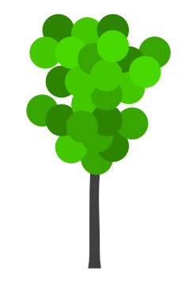

8) Female sea turtles ………………….. their eggs on beaches.
STATIONERY BANK
CAFE
POST OFFICE
LIBRARY
MAIN STREET
You’re here.
F. Describe the ways (5x2=10 pts.).
(Yolu tarif edin)
1. A: Excuse me. How do I get to the cafe?
B: ………………………………………………..
………………………………………………..
………………………………………………..
………………………………………………..
………………………………………………..
2. A: Excuse me. How do I get to the bank?
B: ………………………………………………..
………………………………………………..
………………………………………………..
………………………………………………..
………………………………………………..
young
fat
tall
strong
short

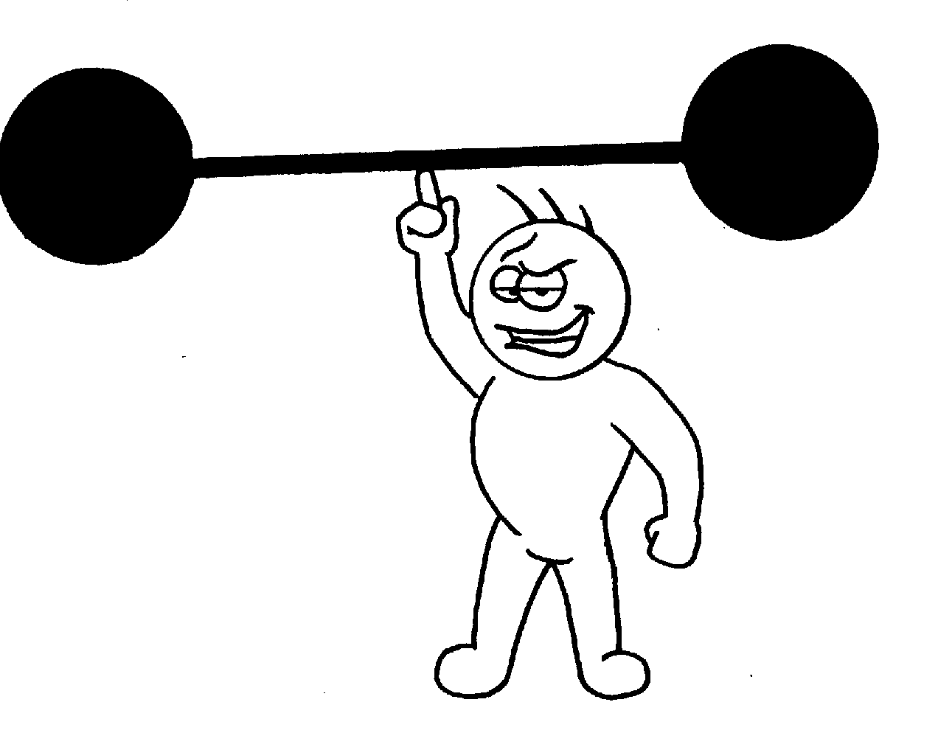
G. Write (2x5=10 pts.)

Age: 33 Age: 25
Weight: 90 kg Weight: 68 kg
Height: 1.70 cm Height: 1. 90 cm

John Alex
For example: Alex is thinner than John.
1.


2.
3.
4.

5.

