2010-2011 AŞAĞI MAHMUTLAR PRIMARY SCHOOL
1ST TERM 2ND WRITTEN ENGLISH EXAM FOR 7TH GRADES
Name / Surname: Class / Number:

A. Boşluğu parantezdeki sıfatın “Comparative” şekliyle doldurunuz. 14 puan

- Hotel Moonlight is ……………………………….. than Hotel Sunshine. (cheap)
- Ali’s brother is ……………………………… than him. (hardworking)
- Cats are ……………………………….. than dogs. (small)
- Kayseri is ………………………………… than Sivas. (modern)
- Mount Ağrı is ……………………………….. than Mount Erciyes. (high)
- Bungee jumping is ……………………………….. than skiing. (dangerous)
- Hamburger is ……………………….……. than cheeseburger. (bad)

B. Verilen ifadeleri resimlerle eşleştiriniz. 10 puan
go by bus - go by bike - go by plane - go by train - go by ship

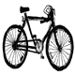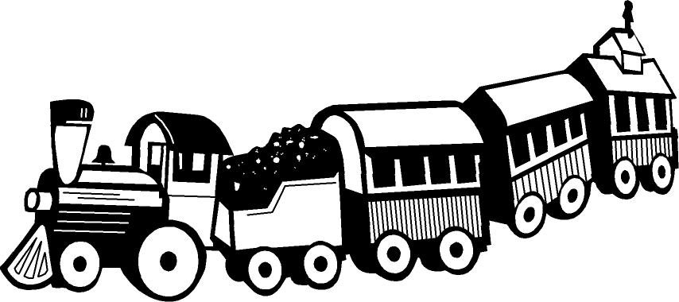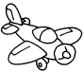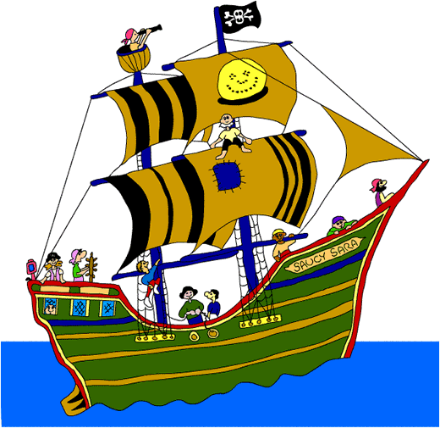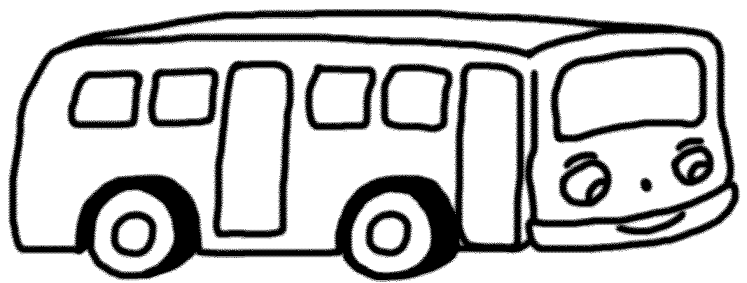

……………………… …………………….… …………………….. …………………… ……………………

C. Boşlukları “but / and / because” ile doldurunuz. 6 puan

- I have a computer ………………….. I can’t use it.
- She doesn’t drink tea ………………….. she dislikes it.
- Next summer we will visit Alanya ………………….. Kuşadası.

D. Bilgisayar parçalarını yazınız. 10 puan

“Case – Printer – Keyboard – Monitor – Mouse”
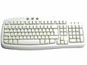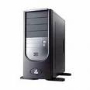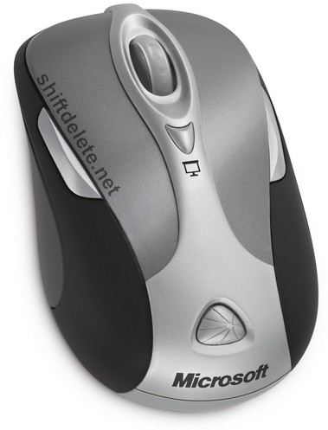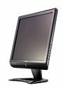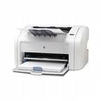
____________ ___________ ___________ _____________ ____________

E. Cümleleri “more – fewer – less” ile tamamlayınız. 9 puan

- Ali has got four pencils. Meral has got six pencils. Meral has got …………….…… pencils.
- There is ………………..…. oxygen in the air now.
- Class A has 40 students. Class B has 35 students. Class B has ………………….. students.

F. Cümleleri “Should - Shouldn’t” ile tamamlayınız. 15 puan

- We …………………….…. protect the environment.
- We …………………….…. cut down the trees.
- We …………………….…. use electricity carefully.
- We …………………….…. use chemicals.
- We …………………….…. save animal and plant species.

G. Doğru seçeneği seçiniz. 36 puan
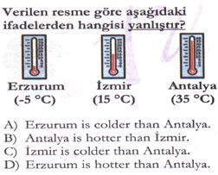

1. Arda is 15 years old. Kemal is 20 years old. Can is 10 years old.
Bu durumda hangisi doğrudur?

a) Arda is younger than Can.
b) Can is older than Kemal.
c) Kemal is older than Arda.
d) Kemal is younger than Arda.

2. Driving a car is ……………… riding a bike.

a) more difficult b) difficulter than
c) difficult d) more difficult than

3. Aşağıdakilerden hangisi diğerlerinden
farklıdır?

a) Go straight ahead and turn left.
b) Could you tell us how to get to the hospital?
c) Is there a bank near here?
d) Can you tell me the way to the bookstore?

4. Verilen eşleştirmelerden hangisi yanlıştır?

a) global warming – küresel ısınma
b) air pollution – hava kirliliği
c) environment – mahalle
d) heritage – miras

5. “Recycle” means ……………..

a) tekrar okuma b) azaltmak
c) geri dönüşüm d) doğal miras
I’m ………… than Lucy
6.

a) fast b) tall c) faster d) taller

7. Aşağıdaki cevaba en uygun soru hangisidir?
Mr. Korkut : ………………..
Mr Cankan : That’s 30 TL.

a) Is there a ticket ?
b) How much is the ticket ?
c) Where is the ticket ?
d) What is this ?

8.

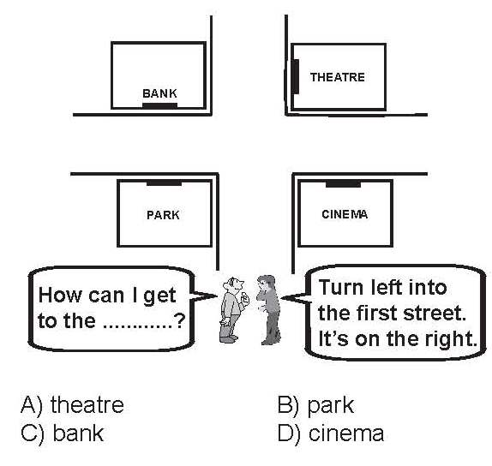
9.

10. Aşağıdakilerden hangisi “çevreci” birisine aittir?

a) We should pollute the rivers and seas.
b) We should help global warming.
c) We should cut down our forests.
d) We should save electricity and water in schools.

11. Aşağıdakilerden hangisi çevremizi korumakla çelişmektedir?
a) We mustn’t turn off the electricity.
b) We must plant trees.
c) We mustn’t use frozen food.
d) We must recycle.


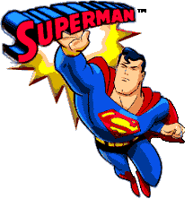
12. Superman is ………….. than Fred.
- stronger
- slower
- weaker
- easier


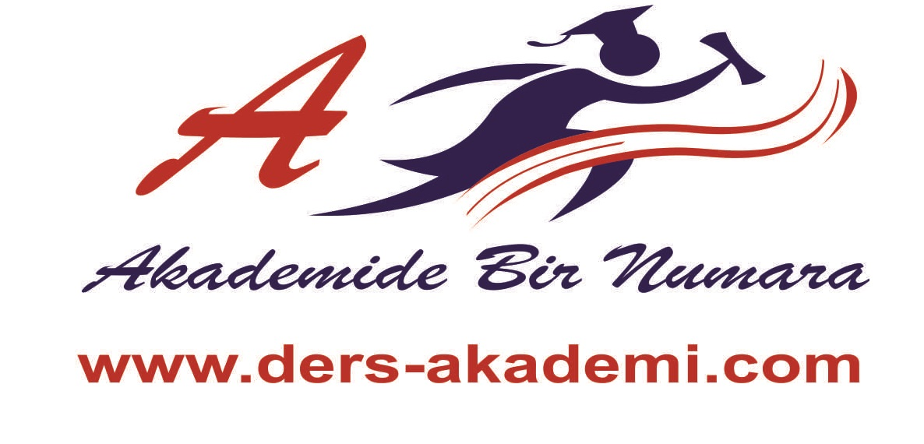
English
MRS.KOÇ

