2010-2011 ACADEMIC YEAR MİTHATPAŞA PRIMARY SCHOOL FIRST TERM SECOND ENGLISH EXAMINATION FOR 7TH GRADES
Name Surname :
Class Number :

A) Answer the questions. (2x4 points=8)

1. Can we recycle a milk bottle?

2. Is Ankara more crowded than Rize?

B) Write their English meanings (4x2points=8)

.................................
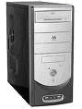 .....................................
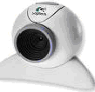 .....................................
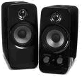 ....................................

C) Make sentences with the comparative forms of adjectives. (2x4 points=8)

1. A sport bike / fast / a touring bike.

2. Reno fluence / expensive / Broadway.

D) Fill in the blanks with the comparative forms of adjectives. (3x4 points=12)

1. I’m.............................than my son. (old)

2. A bike is...........................than a motorbike.

3. Döner is.....................................than pizza. (delicious)

E) Complete the sentences with the correct words.
(4x4=16) (harmful, wastes, global warming, pollution)
1. Don’t leave the heating on! It..................electricity.

2. Chemical are........................to the environment.

3. Traffic fumes causes air................................... .

4. We should start a campaign against........................

F) Make sentences using ‘We should / We shouldn’t’ and the phrases in parenthesis. ( drive smartly / travel a lot by plane / plant trees / leave the television on ) (4x4=16)

1. 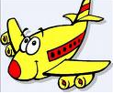

………………………………………………………………………….
2. 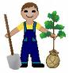

………………………………………………………………………..
3. 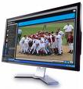

………………………………………………………………………..

4. 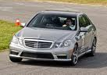

……………………………………………………………………….

G) Choose the correct answer (4x8=32)

1.  She wants to loose weight. What can you suggest or advice her? 1, 2)

- You shouldn’t eat vegetables.
- What about eating too much?
- You should do exercises.
- Why don’t you eat a lot of white bread?

2. A) What about eating too much?
B) You should eat fruit and vegetables.
C) Why don’t you use lift?
D) What about drinking coke and eating meat?

3. A) You hadn’t better throw the rubbish on the ground.
B) You had better throw not the rubbish on the ground.
C) You not had better throw the rubbish on the ground.
D) You had better not throw the rubbish on the ground.

4. Will you listen to music today? No, __________ A) I will B) I won’t C) I don’t D) I’m not

5. Erciyes is...........................................Elmadağ.
A) higher than B) shorter than
C) more short than D) high than

6. “ We should find ways to stop wasting energy.”
‘waste’ means.................................
- to use, consume, spend or expend thoughtlessly, or carelessly.
- Causing injury or damage
- To use again, especially to reprocess
- To choose

7. ‘recycle’ means.......................................
A) to use, consume, spend or expend thoughtlessly, or carelessly.
- Causing injury or damage
- To use again, especially to reprocess
- To choose

8. ‘select’ means.......................................
A) to use, consume, spend or expend thoughtlessly, or carelessly.
- Causing injury or damage
- To use again, especially to reprocess
- To choose

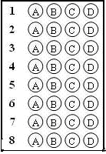

Good luck
