…………..ALİ BAYSAL İLKÖĞRETİM OKULU I.DÖNEM II. İNGİLİZCE YAZILISI
Name: Number: Class:

A) Paragrafı okuyup TRUE(T) OR FALSE(F) yazınız.(5x3=15)
Computers are usully quiker than human beings.they can answer a question or do a job in a very short time.But,are they always better than human beings?Of course,they aren’t.people program them.Computers need people to make programs fort hem.People are the masters of computers
Some factories can do their jobs easily with the help of computers. That’s why they need fewer workers.But who will use the computers?The answer is this:People.
1) ( ) Computers are slower than human beings.
2) ( ) People can program them.
3) ( ) People are the masters of computers.
4) ( ) In some factories there are more workers.
5) ( ) Computers need people in order to be used.

B)Aşağıdaki kelimeleri numaralara göre yazınız .(5x3=15 )
Mouse / system unit / monitor / keyboard / speakers

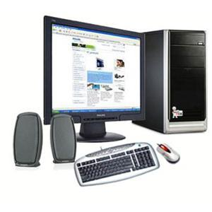
- ………………..
- ………………..
- ………………..
- ………………..
- ………………..

C) Aşağıda verilen kelimeleri boşluklara yerleştiriniz(4x4=16)

Global warming-rainforests-heritage-environment-

1)There is a natural world around us .It is the ……………..
2)People get a lot of things from the past.that is our ……………
3)……………………is a very big problem for the world.
4)……………………..are tropical and they are very important for the ecology of the earth.

D)Aşağıdaki cümlelerin başlangıç ve sonlarını eşleştiriniz(6x4=24)
1)I can’t wear these shoes a)They are too tired.
2)She can’t drink this water b)It is too hot
3)I can’t touch this iron c)There are too much salt in it
4)We can’t drive fast. d)They are too small
5)They can’t go out e)It is too cold

6)He can’t eat this soup f)There are too many cars in the street
1 | 2 | 3 | 4 | 5 | 6

E) Aşağıda verilen kelimeleri kullanarak cümleler kurunuz (7x3=21) superlatives and comparatives
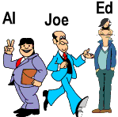

(tall/thin/happy/short/handsome/fat/ugly/sad)

1Al is the…………………………………..
2Joe is the…………………………………..
3Ed is the ……………………………………….
4Al is ………………………………………….
5-Ed is ………………………………………….
6-Joe is ……………………………………………
7-……………………………………………………..
F)Aşağıdaki resimlere göre ‘SHALL’ kullanarak öneri cümleleri oluşturunuz(3x3=9)
1-(swim) A:……………………………….
B:Yes,certainly

2-(read a book) A:……………………………..
B:Yes ,please

3-(go to cinema )A:…………………………..
B:No, thank you
 ESİN KOCABIYIK


