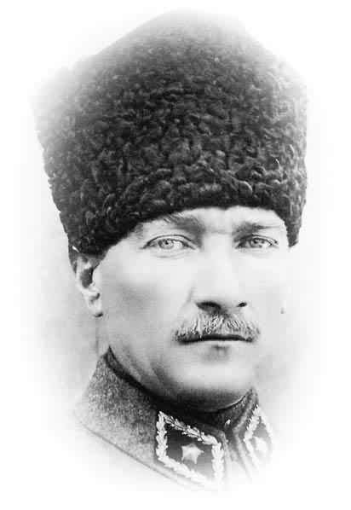
ATAM İZİNDEYİZ...
0…/….2010

Name : MEHMET AKİF PRIMARY SCHOOL
Surname: 2008/2009 ACADEMIC YEAR ENGLISH COURSE
Class: 1st TERM 2nd EXAM OF 7th GRADE
Number:

- VOCABULARY TIME
TOTAL MARK:
- Group the litters into the bins. (9x1=9)
letter | Jelly jar | Margarine tub | Yoghurt pot
Picnic cup | Wine bottle | envelope | Egg carton | Water jug
GLASS PLASTIC PAPER
- FILL IN THE BLANKS WITH THE WORDS (5x1=5)
- Animals,plants,mountains,seas,deserts and rivers are our __________________
- We should start a campaign against …………………………………
- Chemicals are …………………….to the environment
- They have got four layers.They get a lot of rain.They are near the equator and the climate is always wet.They are ______________
- People make new paper, cartons,plastics.That is _________________
rainforests | recycling | Natural heritage | harmful | Global warming
- FIND THE DIFFERENT ONE (4x1=4)
1. a) climate b) weather c) sun d) chemical
2. a) save b) world c) protect d) preserve
3. a) pole b) tropical c) equator d) rainforest
4. a) past b) heritage c) generation d) danger

- WRITE THE ADVANTAGES AND DISADVANTAGES OF USING INTERNET (6x1=6)
- They can find information
- They neglect household duties
- They can stay in touch with their friends
- They get lower marks at school
- They spend more time on
the net
- They have fun

ADVANTAGES:

DISADVANTAGES:

- WRITE THE PARTS OF THE COMPUTER (4x1=4)
- I can help you.I have got numbers and letters.A,b,c,d,1,2,3, ___________
- I can help you.I can open and close computer. __________________
- I can help you.I can print documents,pictures _______________________
- I can help you.You can open and listen to music. ______________________
- MATCH THE WORDS WITH THE SYNONYMS (4x1=4)
- Knowledge 1. To look for
- Communicate 2. information
- Search 3. To choose
- Select 4. To speak or write to people

- GRAMMAR TIME
- WRITE “IF SENTENCE” (3x2=6)
- More forests – more rain _______________________________________________
- Fewer plants – less food _______________________________________________
- More water – more plants ______________________________________________

- FILL IN THE BLANKS WITH “ SHOULD – SHOULDN’T – MUST – MUSTN’T” (4x1=4)
- He is too fat. He ______________ go on a diet.
- If there is red traffic light, you ______________ pass the street.
- You ______________ play computer games too much.
- He spends too much Money and go expensive places. He _________ be rich.

- MAKE SENTENCES (3x2=6)
- the fridge – there – anything – Is – in. . . . . . . . . . . . . . . . . . . . . . . . . . . . . . . . . . . . ?

- see – I – somebody – in – the park. . . . . . . . . . . . . . . . . . . . . . . . . . . . . . . . . . . . .

- OK – Everything – is. . . . . . . . . . . . . . . . . . . . . . . . . . . . . . . . . . . . .

- COMPLETE THE SENTENCES WITH BE GOING TO, WILL (3x2=6)

- Ann has already bought her plane ticket. She ................................ (fly) to Chicago next week.
- A: Do you have any plans for tomorrow?
B: I .................................. (have) a meeting tomorrow morning. However, I am free in the afternoon and in the evening.
- A: I’d really like an ice cream cone, but I didn’t bring any money with me.
B: That’s OK. I ............................ (get) one for you.

- FILL IN THE BLANKS WITH THE COMPERATIVE FORMS OF THE ADJ. (6x1=6)
- My geography lesson marks are ……….……(good) than my maths marks.
- Sarah's house is …………………………... (large) than Shannon's house.
- A Jaguar is…………………………(modern) than.a Fiat.
- Hamburger is ………………………….(bad) than cheeseburger
- Her car is ______________ (dirty) than my car.
- Ali is ……………………………… (intelligent) than Veli.

- MAKE SENTENCES WITH COMPERATIVE (5x2=10)
- Antalya / Bursa / hot ………………………………………………………………..
- English / French / easy ………………………………………………………………………
- A cat / a dog / dangerous ______________________________________
- Elephants / horses / big …………………………………………………………………
- I / my friend / hardworking ………………………………………………………………

- TEST TIME

1. Fred is learning how to surf ………….. the internet.
a) at b) in c) on d) with

2. Tim: ………………….. play hide and seek?
Laura: No. I ………………… hide and seek.
- Let’s / don’t like
- Shall we / don’t like
- Why don’t / like
- How about / like

3. There is natural world around us. It is……………
a) the generation.
b) the environment.
c) the layer.

4. “pay” kelimesinin tanımının yapıldığı seçeneği işaretleyiniz.
A) to choose
B) to give an amount of money you buy something
C) if you don’t do something but do something else
D) the amount of space between two things

5. Öznur’un vermek istediği bilgi hangi seçenekte doğru verilmiştir?
Öznur: “I live in an apartment on the second floor. My room is always tidy. I
haven’t got a computer in my room.”
A) About Me
B) My school
C) My home
D) My friends

6. Resimle ilgili seçeneği işaretleyiniz.
A) Mouse
B) keyboard
C) monitor
D) speakers

GOOD | BAD | SAD | FAR

7. Yukarıdaki sıfatların Comparative şekilleri hangileridir?
a)Good-worse-sader-farer
b)better-worse-sadder-farther
c)Better-bad-sadder-farer
d)gooder-bad-sader-further

8.Aşağıdaki cümledeki boşluğa uygun düşen seçeneği işaretleyiniz.
“Water ………… damages the environment.”

A) waste
B) pollution
C) reduce
D) global warming
9. Resimdeki kişi için söylenebilecek en uygun seçenek
hangisidir?
A) She should take an aspirin
B) She should eat something
C) She should drink some water
D) She should go out

10. Aşağıdakilerden hangisi “World Wildlife Fund”’ın görevlerinden değildir?

- to protect wildlife
- to reduce air pollution
- to reduce water pollution
- to protect historical places

11. Seçeneklerden hangisi aşağıdaki cümleyle aynı anlamda kullanılmıştır?
“You had better not leave electronic devices on”

- You should turn things off
- You shouldn’t turn thins off
- You should leave electronic things on
- You shouldn’t leave electronic things off

12. Carla: ……………………….. eating some fruit?
Stacy: OK. I ………….. fruit.

- Shall we / like
- Let’s / like
- How about / like
- Why don’t we / like
13. Aşağıdakilerden hangisi çevremizi korumakla çelişmektedir?
- We Should Change Light Bulbs
- We Should Drive Smartly
- We Should Recycled Products
- We Should Use Very Hot Water To Wash Our Dishes

14. Aşağıdaki seçeneklerden hangisi diğerlerinden
farklıdır?
A) Important
B) Intelligent
C) Difficult
D) Strong
15. Aşağıdakilerden hangisi internetin olumlu yönü için
bir örnektir?
A) Kids can stay in touch with friends and family
B) Kids get lower marks at school
C) Kids neglect household duties
D) Kids don’t do their homework on time

Note : Each question is 2 points. (30 points)
NİHAL ÖZDAĞ / ELT TEACHE

