Aşağıdaki seçeneklerden hangisi sorunun cevabıdır?

What films do you like?

A) I like watch horror films.
B) I like to watch to horror films.
C) I like watching romantic films.
D) I like romantic films watch.
Aşağıdaki seçeneklerden hangisi cümleyi en doğru şekilde tamamlar?

I ___________ coke, but Semra ________
coffee.

A) like drinking / likes drinking
B) like drink / likes drink
C) like to drink / like to drink
D) like drinking / like to drink

A: What do you do if you have bad
dream?
B: __________________.

A) I become happy.
B) I don't have bad dreams.
C) I feel bad.
D) I never have bad dream.

My books ____ on the table a minute
ago, ____ I can't find them now.

A) was / because
B) were / but
C) weren't / but
D) were / because

Last night, I ______ fairies in my dream.
They____ very beautiful.

A) saw / were B) saw / was
C) weed / were D) see / were

nightmare” kelimesinin Türkçe karşılığı
aşağıdaki seçeneklerin hangisinde
doğru verilmiştir?

A) kabus
B) peri masalı
C) gece bekçisi
D) gece kuşu
Aşağıdaki seçeneklerden hangisi
cümleye göre doğrudur?

When I _______ home, my mother
_________ housework.

A) come / was doing B) came / did
C) came / was doing D) come / do

When the alarm clock ______, I _____
sleeping.

Yukarıdaki cümleyi tamamlayan seçenek
aşağıdakilerden hangisidir?

A) ring – was B) rang - was
C) ringed – were D) rang – were

When I was eleven, I _____ speak English
very well.

A) can B) couldn't to
C) can't D) could

My brother _______ ride a horse when
he was 7, but now he _____ ride it.

A) can – could B) could - can
C) could - couldn'tD) couldn't – can

During the War of Independence, Turkish Army ______ find enough weapons but they _____ win the War of the Independence.

Yukarıdaki ifadede boş bırakılan yerlere
aşağıdaki seçeneklerden hangisi uygun
düşer?

A) could / could B) couldn't/ could
C) couldn't/couldn't D) didn't / did
While Bugs Bunny _______ stories, the
children ______ to him.

A) was reading / was listening
B) read / was listening
C) was reading / were listening
D) reading / were listening to
Last night, I __________ a nightmare. It
was awful.

A) dreamed B) seed
C) drome D) studied

Derya : _______ was him last weekend?
Kamil : In Balıkesir.

Yukarıdaki diyalogu en iyi şekilde
tamamlayan seçeneği işaretleyiniz.

A) When B) How
C) How often D) Where
Aşağıdaki seçeneklerden hangisi doğrudur?
What did Smurfs do yesterday?

A) They played chess.
B) They played chess and then sang a
song.
C) They sang a song and then played
chess.
D) They are sleeping

I couldn't swim when I was a little girl
_____now, I can swim.

A) because B) but
C) for D) and

Aşağıdaki kelimelerden düzgün bir
cümle kurulmak istense seçeneklerden
hangisi doğrudur?

television-doesn't-listening-music-prefer to- Ayhan-watching-to

A) Ayhan doesn't listening to music to
watching television.
B) Ayhan prefers listening music to
doesn't watching to television.
C) Ayhan doesn't prefer listening to
music to watching television.
D) Ayhan doesn't prefer listening music
to watching to television.

" _______ do you like, coke or fruit juice?
Yukarıdaki boşluğa aşağıdaki seçeneklerden hangisi gelir?
A) which one B) one
C) which ones D) ones

"attractive" kelimesinin eş anlamlısı
aşağıdakilerden hangisidir?
A) beautiful B) unhealthy
C) ugly D) wealthy

Aşağıdaki boşluğa seçeneklerden
hangisi gelmelidir?

Büþra : _________________________
Gülþen : I am sorry, I have an exam
tomorrow, I have to study.

A) Let's go to the cinema.
B) Let's study maths.
C) Have you got a pencil?
D) Do you have any problem?

A: ________ have you been waiting
here?

B: I've been waiting here for two hours.

Yukarıdaki cümleyi tamamlayan soru
kalıbı aşağıdaki seçeneklerden hangisidir?

A) How B) How long
C) When D) Why

I ________ my homework yet.

Yukarıdaki cümleyi tamamlayan en
uygun seçenek aşağıdakilerden hangisidir?

A) haven't finished B) have finished
C) have finish D) haven't finish

Aşağıdaki seçeneklerden hangisi
doğrudur?

A: I am very bored today.

B: _________________ ?

A) Let's go to the cinema
B) Shall we go to the cinema
C) Go to the cinema
D) Ok, that's a good idea

Aşağıdaki boşluğa uygun en uygun
seçenek aşağıdakilerden hangisidir?

A: Why don't you eat your hamburger?
B: ________ I'm not hungry.

A) And B) So
C) Because D) To

Aşağıdaki cümleyi en uygun tamamlayan seçenek aşağıdakilerden hangisidir?

İstanbul is the most beautiful city I _____ ever _____.

A) has – see B) have - seen
C) have – saw D) has – seen

Aşağıdaki cümlelere en uygun seçenek
aşağıdakilerden hangisidir?

A: Have you ______ travelled to Paris?

B: No, I have ______ been there.

A) ever – never B) never - ever
C) been – ever D) been – never

Aşağıdaki cümleyi en uygun tamamlayan seçenek aşağıdakilerden hangisidir?

I am not hungry. I've ______ eaten a
hamburger.

A) yet B) already
C) since D) for

A: How long have you been in Paris?

B: I have been there ____ two weeks.

Aşağıdaki seçeneklerden hangisi
boşluğa uygundur?

A) for B) since
C) yet D) already

Mehmet __________ his work, yet.

A) hasn't finished B) have finished
C) has finished D) didn't finish

A: Where is your mother?

B: She _________ to Paris.

A) have gone B) has gone
C) gone D) going

Aşağıdaki seçeneklerden hangisi
doğrudur?

A: ________ can I stay?

B: You can stay at a hotel.

A) Where B) How
C) When D) What

Tom is very careful. He climbed up the
ladder ________.

A) careful B) carefully
C) care D) carely

Aşağıdaki cümlede boşluğu en uygun
şekilde tamamlayan seçenek aşağıdakilerden hangisidir?

I prefer romantic films _______ horror
films.

A) but B) for
C) and D) to

In the exam, I couldn't answer all the
questions because they were very_____.

A) easy B) difficult
C) strong D) hardly

Aşağıdaki boşluğa en uygun seçenek
aşağıdakilerden hangisidir?

Her English is good enough to _______

A) talk to tourist B) catch mice
C) go to a disco D) watch tv

Hasan is tall ________ Murat Boz is taler than him.

A) but B) because
C) or D) so

I don't like this book. It is very____.

A) boring B) interesting
C) enjoyable D) good

She is good at _________ English, but
bad at speaking French.

Yukarıdaki cümlede boş bırakılan yere
gelebilecek en uygun seçenek aşağıdakilerden hangisidir?

A) to speak B) speaking
C) speak D) spoke

Aşağıdaki cümleyi en uygun tamamlayan seçenek aşağıdakilerden hangisidir?

A: Why do you want to be an English
teacher?

B: _______ I love English very much.

A) In case B) So that
C) Because D) In order to

A: _____ are you doing here?

B : I am waiting for the bus.

A) Why B) How
C) What D) When

My brother is very_____. He can answer
all of the questions that I ask.

A) clever B) interesting
C) happy D) unhappy

"Would you ___ to come to the cinema
with me tonight?
"
A) want B) like to
C) 'd like to D) like

Aşağıdaki seçeneklerden hangisi
doğrudur?

When the teacher _______, the students
_____________ a song.

A) was coming - sang
B) came - were singing
C) came - sang
D) was coming - were singing

Yukarıdaki resmi en iyi şekilde ifade
eden seçeneği işaretleyiniz.

A) Ali likes playing football.
B) Ali likes watching soup opera.
C) Ali likes washing the dishes.
D) Ali likes watching football match

I ________ go to the cinema tonight.

A) am wanting
B) wants
C) want
D) want to

Aşağıdakilerden hangisi doğrudur?
Which do you prefer, studying English or studying French?

A) I prefer studying English to studying
French.
B) I prefer studying English to speak
French.
C) I prefer to study English to French.
D) I prefer studying English for spaeking French.

A : _____ we eat ''sushi'' in the new
Chinese restaurant?

B : That's a good idea.
Yukarıdaki cümleyi en uygun tamamlayan seçenek hangisidir?

A) Would B) Can
C) Shall D) Let's

Aşağıdaki seçeneklerden hangisi doğrudur?
What films do you prefer?

A) I prefer watching horror films.
B) I prefer to watch to horror films.
C) I prefer to watching romantic films.
D) I like romantic films watch

Aşağıdaki seçeneklerden hangisi cümleyi en doğru şekilde tamamlar?

I ___________ coke. But Ayşe _________ coffee.

A) like drinking / likes drinking
B) like drink / likes drink
C) like to drink / like to drink
D) like drinking / like to drink

Aşağıdaki seçeneklerden hangisi cümleyi en doğru şekilde tamamlar?

A: Today is Sunday. _______ go swimming.

B: That's a good idea.

A) Shall B) Let's
C) Can we D) Are we

Aşağıdaki seçeneklerden hangisi cümleyi en doğru þekilde tamamlar?

I prefer ________ to pop music.
A) listen B) listening
C) to listening D) to not listening

A: Why weren't you at the party last night, Cem?

B:_____ I don't like parties. I prefered
staying at home.

A) But B) Because
C) For D) In order

A: What kind of books do you like reading?

B: ______________.

A) No, I don't like reading historical
books.
B) I like reading historical books.
C) I don't like reading romantic books.
D) I like watching comedy foods.

Your mother is tired. What should she
do?

A) She should clean the house
B) She should go shopping
C) She should sleep
D) She should dance

The clowns are ________.

A) stingy B) funny
C) famous D) sensitive

He helps other people. He is ________.

A) rude B) self - conceited
C) helpful D) awkward

Aşağıdakilerden hangisi diğerlerinden
farklı bir grupta yer alır?

A) always B) never
C) sometimes D) today

Fatih likes swimming ____ he doesn't like sunbathing.

Aşağıdaki seçeneklerden hangisi yukarıdaki
ifadeyi en iyi şekilde tamamlar?

A) but B) because
C) and D) for

“lazy” kelimesinin zıt anlamlısı aşağıdakilerden hangisidir?

A) good B) hardworking
C) unhappy D) unusual

You always think possitively.You are
an……..….person.

A)Pessimistic B)Optimistic
C)Pessim D)Optic

Hi! My name is Murat and I paint pictures in at my home.

Aşağıdaki resimlerden hangi Murat' in
mesleğidir?

“Serhat is going to the hospital ________
he is ill.”

Yukarıdaki ifadeyi en iyi şekilde tamamlayan
seçeneği işaretleyiniz.

A) because B) but
C) for D) and

"My sister read newspapers everyday.”

Yukarıdaki ifadeyi anlatan resim aşağıdaki
seçeneklerden hangisinde verilmiştir?

"which ____ do you like, coffee or tea?

A) which one B) ones
C) which ones D) one

which ______ do you like best, sandals
or trainers?

A) one B) ones
C) one to D) one of

A: When did you come home?

B: Two hours ______.

Aşağıdaki seçeneklerden hangisi cümleyi en uygun şekilde tamamlar?

A) ago B) for
C) since D) even

Last night, I ______ fairies in my dream.
They____ very beautiful.

A) saw / were B) saw / was
C) weed / were D) see / were
“nightmare” kelimesinin Türkçe karşılığı aşağıdakidaki seçeneklerin hangisinde doğru verilmiştir?

A) kabus B) peri masalı
C) gece bekçisi D) gece kuşu

Soruda baloncukta boş bırakılan cümleyi en iyi tamamlayan ifade hangi seçenektedir?
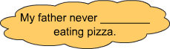
A)would like B)Want to
C)doesn’t like D)prefers
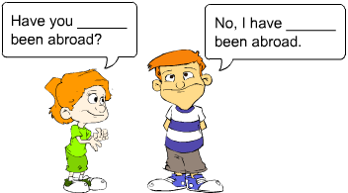
Soruda konuşma balonlarında boş bırakılan yerleri en anlamlı şekilde tamamlayacak seçeneği işaretleyiniz.
A)never/ever B)ever/never
C)never/never D)ever/ever
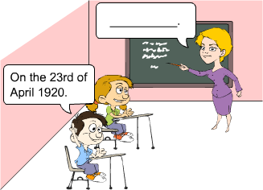
Öğrencinin verdiği cevaba göre, öğretmenin sorusuyla ilgili boş bırakılan yere uygun olan seçeneği yerleştiriniz.
A | When did Atatürk establish the Great National Assembly?
B | Did Atatürk arrive in Samsun in 1919?
C | When was Atatürk born?
D | Was he successful in Çanakkale?

Aşağıdaki soruda, konuşma balonunda boş bırakılan yere uygun olan ifade hangisidir?
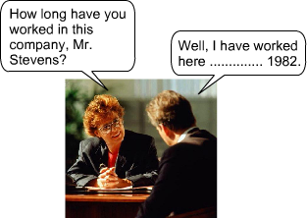
A) at B) since C) in D)for
Aşağıdaki soruda, konuşma balonunda boş bırakılan yere uygun olan ifade seçeneklerden hangisindedir?
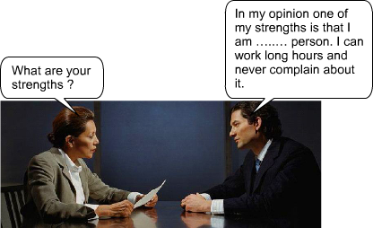
A) an irresponsible B) a hardworking
C) a dishonest D) an imaginative
Aşağıdaki soruda, konuşma balonunda boş bırakılan yere uygun olan ifade seçeneklerden hangisindedir?
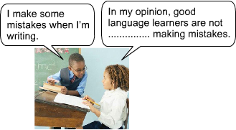
A) good at B) good
C) afraid D) afraid of
Aşağıdaki soruda, boş bırakılan yere uygun olan ifade seçeneklerden hangisindedir?
A : What ............ when your mother came in?
B : I was talking on the phone

A) have you done B) are you doing
C) were you doing D) did you do

Aşağıdaki cümleyi anlam olarak en uygun şekilde tamamlayan kelimeyi işaretleyiniz.
I didn't go to school today ............ I am ill.
A)but B)also C)because D)while
Cümlede geçen tarihin doğru yazılışını işaretleyiniz.
Republic Day is on 29th October.
A | thirtieth of October
B | twenty-nine of October
C | the twentieth of October
D | the twenty-ninth of October
Aşağıdaki cümlede boş bırakılan yerlere hangi ifadelerin gelmesi gerekir?
I don’t like ............ computer games, but I like ............ detective novels
A)playing/reading B)play/read
C)playing/read D)played/read
Konuşma balonundaki cümleyi doğru tamamlayan sözcüğü seçiniz.
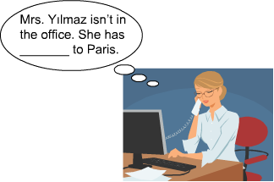
A)seen B)gone C)been D)done
Aşağıdaki diyalogda boş bırakılan yere aşağıdaki ifadelerden hangisinin gelmesi gerekir?
Merve : I hate noisy people.
Seda : ................. !
A)I think B) me too
C)I don’t think D)me neither

